**‘A STUDY ON THE CUSTOMER PERCEPTION TOWARDS INTERNET BANKING IN KERALA’**

***AT***

**AYRUZ DATA MARKETING PVT LTD, TECHNOPARK, TRIVANDRUM**

*Submitted in partial fulfillment of requirement for the award of degree of Master of Business Administration of*



**University of Kerala,**

Thiruvananthapuram

2012-2014

*Submitted by*

**DIVYA RACHEL JOHNS**

**Reg. No: 12810039**

*Under the guidance of*

**Mr. ALEX KOSHY**

*(Assistant Professor – Operations)*



***T K M INSTITUTE OF MANAGEMENTMUSILIAR HILLS,***

***KARUVELIL P.O, KOLLAM 691505***

**DECLARATION**

I, the undersigned, hereby declare that this project report entitled “**A STUDY ON THE CUSTOMER PERCEPTION TOWARDS INTERNET BANKING IN KERALA”** at **AYRUZ DATA MARKETING PVT LTD, TECNOPARK, TRIVANDRUM** has been written and submitted under the guidance of **Mr. Alex Koshy** and is my original work.

I assert that the statements made and conclusions drawn are an outcome of the project work. I further declare that to the best of my knowledge and belief that the project report does not contain any part of work which has been submitted for the award of any other degree/diploma /certificate in this University or any other University.

Place: Kollam DIVYA RACHEL JOHNS

Date:

**ACKNOWLEDGEMENT**

*The success of a project depends upon framework and cooperation of various people involved either directly or indirectly. I take this opportunity to express my gratitude to all those who helped in this project.*

*First and foremost I thank God almighty for his blessing for the successful completion of this work. I take this opportunity to acknowledge my indebtedness to all persons who have me in completing my work.*

*I would like to thank* ***Dr. A.VISWANATHAN*** *(Director of TKM Institute of Management) who has always been a potential source of inspiration and advice without whom this would not have been a fruitful effort.*

*Iam very happy to express my gratefulness to* ***Mr. ALEX KOSHY*** *(Assistant Professor of T.K.M Institute of Management) for her valuable suggestions and constructive reviews on the topic of this study.*

*I express my sincere gratitude to* ***Mr. SANIL SUBASH CHANDRA BOSE, Founder and Business consultant, Ayruz Web Holdings, Technopark, Trivandrum*** *for hissincere support and valuable suggestions during the project period.*

*I take this opportunity to express heartfelt thanks to all* ***staff*** *of* ***Ayruz Web Holdings*** *for their cooperation and tremendous support extended to me without which this work could not have been completed successfully.*

*Finally I wish to thank my family and friends and express my sincere gratitude to them for their support; guidance, protection and blessing those were showered upon me throughout the endeavor.*

**CONTENTS**

|  |  |  |
| --- | --- | --- |
| **CHAPTER** | **TITLE** | **PAGE NO.** |
|  | **Executive summary** | 1 |
|  | **Introduction** | 2 |
| 1.1 | Background of the study | 3 |
| 1.2 | Industry profile | 5 |
| 1.3 | Company profile | 20 |
| 1.4 | Scope and objective of the study | 23 |
| 1.5 | Limitations to the study | 24 |
| 1.6 | Chapterisation | 25 |
| II. | **Literature review** | 26 |
| III. | **Research Methodology** | 48 |
| 3.1 | Objectives of the study | 49 |
| 3.2 | Scope of the study | 50 |
| 3.3 | Research Design | 50 |
| 3.4 | Methodology of the study | 51 |
| 3.5 | Hypothesis used for the study | 54 |
| IV. | **Data Analysis and Interpretation** | 55 |
| V. | **Findings &Suggestions** | 82 |
| 5.1 | Findings | 83 |
| 5.2 | Suggestions | 86 |
| 6 | Conclusion | 87 |
|  | **Bibliography** | 88 |
|  | **Appendix** | 93 |

**List of tables**

|  |  |  |
| --- | --- | --- |
| **SL.NO** | **TITLE** | **PAGE NO** |
| 4.1 | Gender of the respondents | 56 |
| 4.2 | Age group of the respondents | 57 |
| 4.3 | Occupation of the respondents | 58 |
| 4.4 | Annual income of respondents | 59 |
| 4.5 | Bank account | 60 |
| 4.6 | Use of internet banking facility | 61 |
| 4.7 | Mode of access of internet bank account | 62 |
| 4.8 | Frequency of usage | 63 |
| 4.9 | Reason for choosing a particular bank | 64 |
| 4.10 | Overall satisfaction | 66 |
| 4.11 | Reason for not opening an internet bank account | 67 |
| 4.12 | Priority of internet banking services used by customers | 68 |
| 4.13 | Internet banking experience based on various parameters | 69 |
| 4.14 | Problems faced by internet banking users | 70 |
| 4.15 | Banks used by internet bank users | 71 |
| 4.16 | Analysis to check whether there is any relationship between age and frequency of use -Chi-square test | 72 |
| 4.17 | Analysis to check whether there is any relationship between age and mode used for accessing internet banking facility-Chi-square test | 73 |
| 4.18 | Analysis to check whether there is any relationship between annual income and reason for choosing a particular bank -Chi-square test | 74 |
| 4.19 | Analysis to check whether there is any relationship between gender and use of internet banking facility -Chi-square test | 75 |
| 4.20 | Analysis to check whether there is any relationship between annual income and use of internet banking facility -Chi-square test | 76 |
| 4.21 | Analysis to check whether there is any relationship between occupation and mode used for accessing internet banking facility -Chi-square test | 77 |
| 4.22 | Analysis to check whether there is any relationship between occupation and frequency of use of internet banking facility -Chi-square test | 78 |
| 4.23 | Parameters influencing the perception of customer toward internet banking – Reliability statistics | 79 |
| 4.24 | Parameters influencing the perception of customer toward internet banking- item statistics | 79 |
| 4.25 | Analysis to check whether there is any difference in the ranking of various factors influencing banking experience and income level - ANNOVA | 80 |

**List of charts**

|  |  |  |
| --- | --- | --- |
| **SL.NO** | **TITLE** | **PAGE NO** |
| 4.1 | Gender of the respondents | 56 |
| 4.2 | Age group of the respondents | 57 |
| 4.3 | Occupation of the respondents | 58 |
| 4.4 | Annual income of respondents | 59 |
| 4.5 | Bank account | 60 |
| 4.6 | Use of internet banking facility | 61 |
| 4.7 | Mode of access of internet bank account | 62 |
| 4.8 | Frequency of usage | 63 |
| 4.9 | Reason for choosing a particular bank | 64 |
| 4.10 | Overall satisfaction | 66 |
| 4.11 | Reason for not opening an internet bank account | 67 |
| 4.12 | Priority of internet banking services used by customers | 68 |
| 4.13 | Internet banking experience based on various parameters | 69 |
| 4.14 | Problems faced by internet banking users | 70 |
| 4.15 | Banks used by internet bank users | 71 |
| 4.16 | Analysis to check whether there is any relationship between age and frequency of use -Chi-square test | 72 |
| 4.17 | Analysis to check whether there is any relationship between age and mode used for accessing internet banking facility-Chi-square test | 73 |
| 4.18 | Analysis to check whether there is any relationship between annual income and reason for choosing a particular bank -Chi-square test | 74 |
| 4.19 | Analysis to check whether there is any relationship between gender and use of internet banking facility -Chi-square test | 75 |
| 4.20 | Analysis to check whether there is any relationship between annual income and use of internet banking facility -Chi-square test | 76 |
| 4.21 | Analysis to check whether there is any relationship between occupation and mode used for accessing internet banking facility -Chi-square test | 77 |
| 4.22 | Analysis to check whether there is any relationship between occupation and frequency of use of internet banking facility -Chi-square test | 78 |

**Executive Summary**

A study has been conducted on “**A study on the customer perception towards internet banking in Kerala**” at Ayruz Data Marketing Private Ltd, Technopark, Trivandrum.

Today, Indian banks are working under intense competition from new generation banks and foreign banks. Banks are embracing new and cost effective delivery channel offering attractive value added services is the only way to retain and attract the customers. Banking Industry is experiencing rapid changes due to availability and usage of alternate channels. Today's banking takes place increasingly online, financial institutions deliver their services via various electronic channels and the importance of a traditional branch network has declined. The tremendous advances in technology and the aggressive infusion of information technology had brought in a paradigm shift in banking operations **(Gerrard, P. and Cunningham, J.B. (2004)**.

One of the most fundamental changes in the banking industry has been the consumer movement from traditional branch banking to more stand-alone banking. In other words, a move towards using electronic delivery channels such as the Internet, telephone and mobile phones in private banking. Internet banking is a new type of information system that uses the innovative resources of the Internet to enable customers to effect financial activities in virtual space (Shih and Fang, 2004). Internet banking in this study is defined as an Internet portal, through which customers can use different kinds of banking services ranging from bill payment to making investments.

It provides enormous benefits to consumers like access his accounts at anytime and from any location with ease and least cost. With the help of the Internet, banking is no longer bound to time or geography. Consumers all over the world have relatively easy access to their accounts 24 hours per day, seven days a week. Therefore, Internet banking provides many benefits to both banks and their customers **(Karjaluoto, Mattila and Pento, 2002).**

The perception of customers towards internet banking differs widely. The study is to identify these perceptions and also to assess the factors that influence perceptions.

**CHAPTER 1**

**INTRODUCTION**

**1.1 BACKGROUND OF THE STUDY**

Today, Indian banks are working under intense competition from new generation banks and foreign banks. Banks are embracing new and cost effective delivery channel offering attractive value added services is the only way to retain and attract the customers. Banking Industry is experiencing rapid changes due to availability and usage of alternate channels. Technology plays a major role in the development of alternate channels and interactions between customers and banks. Today's banking takes place increasingly online, financial institutions deliver their services via various electronic channels and the importance of a traditional branch network has declined. The tremendous advances in technology and the aggressive infusion of information technology had brought in a paradigm shift in banking operations (Gerrard, P. and Cunningham, J.B. (2004)). Technology has become an increasingly vital element in the competitive landscape of the financial service industry. The recent developments have created a totally new service concept and service environment.

Technology has changed the very nature of selling and buying financial services. One of the most fundamental changes in the banking industry has been the consumer movement from traditional branch banking to more stand-alone banking. In other words, a move towards using electronic delivery channels such as the Internet, telephone and mobile phones in private banking Lu, J., Yu, C.S., Liu, C. and Yao, J.E. (2003), Internet banking is a new type of information system that uses the innovative resources of the Internet to enable customers to effect financial activities in virtual space (Shih and Fang, 2004). Internet banking in this study is defined as an Internet portal, through which customers can use different kinds of banking services ranging from bill payment to making investments. Therefore banks' Web sites that offer only information on their pages without possibility to do any transactions are not qualified as Internet banking services.

The banking industry in Kerala is facing unprecedented competition from non traditional banking institutions, which now offer banking and financial services over the Internet Lu, J., Yu, C.S., Liu, C. and Yao, J.E. (2003),. The deregulation of the banking industry coupled with the emergence of new technologies, are enabling new competitors to enter the financial services market quickly and efficiently. The internet is revolutionizing the banking industry to conduct its business through online familiarly called as Internet banking or online banking. It offers personalized services through the web portals. Internet banking involves use of internet for delivery of banking products & services. It provides enormous benefits to consumers like access his accounts at anytime and from any location with ease and least cost. The emergence of the Internet has had a significant impact on the diffusion of electronic banking. With the help of the Internet, banking is no longer bound to time or geography. Consumers all over the world have relatively easy access to their accounts 24 hours per day, seven days a week. Therefore, Internet banking provides many benefits to both banks and their customers (Karjaluoto, Mattila and Pento, 2002). One advantage of banks going online is the potential savings in the cost of maintaining a traditional branch network Shih and Fang, 2004). Turban et al. (2000) indicated that Internet banking is extremely beneficial to customers because of the savings in costs, time and space it offers, its quick response to complaints, and its delivery of improved services, all of which benefits make for easier banking. This project highlights the customer perception towards the Internet banking in Kerala.

Banking is a customer oriented service industry, where the customer is in focus and customer service is a differentiating factor. The traditional functions of banking are very limited one. Economic reforms initiated by the government of India in the early 1990’s have brought about a sea change in the operational environment of the financial sector and the functioning outlook of Indian banks. Customer expects many services with the various deliver mode in the speedy and economically. Modern World Bank is fully based on computerization connected with the Internet. Internet banking provides new opportunities for banks to expand their markets and services not only in the local level but also into the world level. The Internet banking revolution has made it possible to provide ease and flexibility in banking operations to the benefit of customers. The e- banking has made the customer say goodbye to limited time banking and local area operation. Due to the enormous benefits of Internet banking most of the customer opt for Internet Banking services. This study provides an opportunity to know role of Internet banking service in commercial banks and its customer satisfaction is analyzed. The present study also focuses on the awareness of the technology oriented services offered to their customers in Kerala.

However, acceptance of this new technology has not been equal in all parts of the world (Karjaluoto, Mattila and Pento, 2002). Although Internet banking may help banks to reduce costs, there are important considerations, such as, the extent to which retail bank customers use new forms of banking, that is, the factors that influence intention toward using another forms of banking and adoption differences between different forms of banking. These considerations are very important to the practitioners who plan and promote new forms of banking in the current competitive market. Internet banking that has revolutionized the banking industry worldwide has turned out to be the nucleus issue of various studies all over the world. This study focuses on perception of customers towards internet banking in Kerala and evaluates reasons which prevent them from using this technology.

**1.2 INDUSTRY PROFILE**

**1.2.1 Banking industry profile**

Indian banking is the lifeline of the nation and its people. Banking has helped in developing the vital sectors of the economy and usher in a new dawn of progress on the Indian horizon. A bank is a financial institution and a financial intermediary that accepts deposits and channels those deposits into lending activities, either directly or through capital markets. A bank connects customers that have capital deficits to customers with capital surpluses. Due to their critical status within the financial system and the economy generally, banks are highly regulated in most countries. They are generally subject to minimum capital requirements which are based on an international set of capital standards, known as the Basel Accords.

The sector has translated the hopes and aspirations of millions of people into reality. But to do so, it has had to control miles and miles of difficult terrain, suffer the indignities of foreign rule and the pangs of partition. Today, Indian banks can confidently compete with modern banks of the world.

Before the 20th century, usury, or lending money at a high rate of interest, was widely prevalent in rural India. Entry of Joint stock banks and development of Cooperative movement have taken over a good deal of business from the hands of the Indian money lender, who although still exist, have lost his menacing teeth.

In the Indian Banking System, Cooperative banks exist side by side with commercial banks and play a supplementary role in providing need-based finance, especially for agricultural and agriculture-based operations including farming, cattle, milk, hatchery, personal finance etc. along with some small industries and self-employment driven activities. Generally, co-operative banks are governed by the respective co-operative acts of state governments. But, since banks began to be regulated by the RBI after 1st March 1966, these banks are also regulated by the RBI after amendment to the Banking Regulation Act 1949. The Reserve Bank is responsible for licensing of banks and branches, and it also regulates credit limits to state co-operative banks on behalf of primary co-operative banks for financing SSI units.

Banking in India originated in the first decade of 18th century with The General Bank of India coming into existence in 1786. This was followed by Bank of Hindustan. Both these banks are now defunct. After this, the Indian government established three presidency banks in India. The first of three was the Bank of Bengal, which obtains charter in 1809, the other two presidency bank, viz., the Bank of Bombay and the Bank of Madras, were established in 1840 and 1843, respectively. The three presidency banks were subsequently amalgamated into the Imperial Bank of India (IBI) under the Imperial Bank of India Act, 1920 –which is now known as the State Bank of India.

A couple of decades later, foreign banks like Credit Lyonnais started their Calcutta operations in the 1850s. At that point of time, Calcutta was the most active trading port, mainly due to the trade of the British Empire, and due to which banking activity took roots there and prospered. The first fully Indian owned bank was the Allahabad Bank, which was established in 1865.By the 1900s, the market expanded with the establishment of banks such as Punjab National Bank, in 1895 in Lahore and Bank of India, in 1906, in Mumbai – both of which were founded under private ownership. The Reserve Bank of India formally took on the responsibility of regulating the Indian banking sector from 1935. After India’s independence in 1947, the Reserve Bank was nationalized and given broader powers.

As the banking institutions expand and become increasingly complex under the impact of deregulation, innovation and technological up gradation, it is crucial to maintain balance between efficiency and stability. During the last 30 years since nationalization tremendous changes have taken place in the financial markets as well as in the banking industry due to financial sector reforms. The banks have shed their traditional functions and have been innovating, improving and coming out with new types of services to cater emerging needs of their 5customers. Banks have been given greater freedom to frame their own policies.

Rapid advancement of technology has contributed to significant reduction in transaction costs, facilitated greater diversification of portfolio and improvements in credit delivery of banks. Prudential norms, in line with international standards, have been put in place for promoting and enhancing the efficiency of banks. The process of institution building has been strengthened with several measures in the areas of debt recovery, asset reconstruction and securitization, consolidation, convergence, mass banking etc.

Despite this commendable progress, serious problem have emerged reflecting in a decline in productivity and efficiency, and erosion of the profitability of the banking sector. There has been deterioration in the quality of loan portfolio which, in turn, has come in the way of bank’s income generation and enhancement of their capital funds. Inadequacy of capital has been accompanied by inadequacy of loan loss provisions resulting into the adverse impact on the depositors‟ and investors‟ confidence. The Government, therefore, set up Narasimham Committee to look into the problems and recommend measures to improve the health of the financial system.

The acceptance of the Narasimham Committee recommendations by the Government has resulted in transformation of hitherto highly regimented and over bureaucratized banking system into market driven and extremely competitive one. The massive and speedy expansion and diversification of banking has not been without its strains. The banking industry is entering a new phase in which it will be facing increasing competition from non-banks not only in the domestic market but in the international markets also. The operational structure of banking in India is expected to undergo a profound change during the next decade. With the emergence of new private banks, the private bank sector has 6become enriched and diversified with focus spread to the wholesale as well as retail banking. The existing banks have wide branch network and geographic spread, whereas the new private banks have the clout of massive capital, lean personnel component, the expertise in developing sophisticated financial products and use of state-of-the-art technology.

Gradual deregulation that is being ushered in while stimulating the competition would also facilitate forging mutually beneficial relationships, which would ultimately enhance the quality and content of banking. In the final phase, the banking system in India will give a good account of itself only with the combined efforts of cooperative banks, regional rural banks and development banking institutions which are expected to provide an adequate number of effective retail outlets to meet the emerging socio-economic challenges during the next two decades. The electronic age has also affected the banking system, leading to very fast electronic fund transfer. However, the development of electronic banking has also led to new areas of risk such as data security and integrity requiring new techniques of risk management.

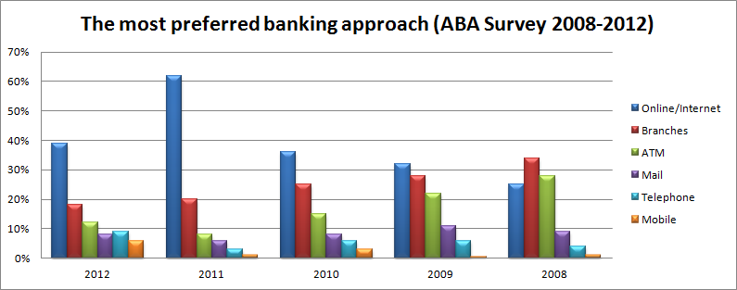

Cooperative (mutual) banks are an important part of many financial systems. In a number of countries, they are among the largest financial institutions when considered as a group. Moreover, the share of cooperative banks has been increasing in recent years; in the sample of banks in advanced economies and emerging markets analyzed in this paper, the market share of cooperative banks in terms of total banking sector assets increased from about 9 percent in mid-1990s to about 14 percent in 2004.

**1.2.2 Structure of Indian Banking Industry**

As per Section 5(b) of the Banking Regulation Act 1949: “Banking” means the accepting, for the purpose of lending or investment, of deposits of money from the public, repayable on demand or otherwise, and withdrawal by cheque, draft, order or otherwise.”

All banks which are included in the Second Schedule to the Reserve Bank of India Act, 1934 are scheduled banks. These banks comprise Scheduled Commercial Banks and Scheduled Cooperative Banks. Scheduled Commercial Banks in India are categorised into five different groups according to their ownership and / or nature of operation. These bank groups

are:

(i) State Bank of India and its Associates,

(ii) Nationalised Banks,

(iii) Regional Rural Banks,

(iv) Foreign Banks and

(v) Other Indian Scheduled Commercial Banks (in the private sector).

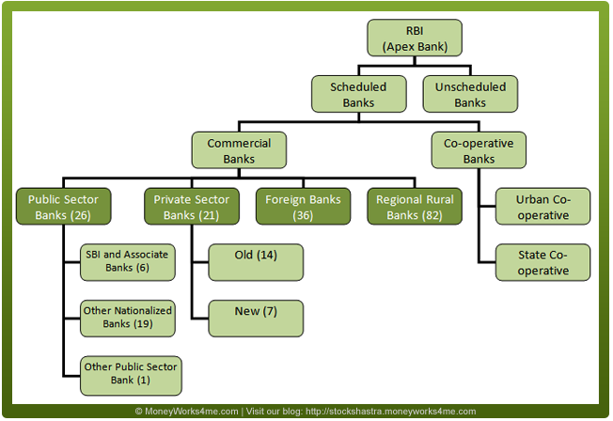

Besides the Nationalized banks (majority equity holding is with the Government), the State Bank of India (SBI) (majority equity holding being with the Reserve Bank of India) and the associate banks of SBI (majority holding being with State Bank of India), the commercial banks comprise foreign and Indian private banks. While the State bank of India and its associates, nationalized banks and Regional Rural Banks are constituted under respective enactments of the Parliament, the private sector banks are banking companies as defined in the Banking Regulation Act. These banks, along with regional rural banks, constitute the public sector (state owned) banking system in India.

The Public Sector Banks in India are back bone of the Indian financial system. The cooperative credit institutions are broadly classified into urban credit cooperatives and rural credit cooperatives. Scheduled Co-operative Banks consist of Scheduled State Co-operative Banks and Scheduled Urban Co-operative Banks. Regional Rural Banks (RRB’s) are state sponsored, regionally based and rural oriented commercial banks. The Government of India promulgated the Regional Rural Banks Ordinance on 26th September 1975, which was later replaced by the Regional Rural Bank Act 1976. The preamble to the Act states the objective to develop rural economy by providing credit and facilities for the development of agriculture, trade, commerce, industry and other productive activities in the rural areas, particularly to small and marginal farmers, agricultural labourers, artisans and small entrepreneurs.

**1.2.3 Bank Nationalization**

The Government of India issued an ordinance and nationalised the 14 largest commercial banks with effect from the midnight of July 19, 1969. Within two weeks of the issue of the ordinance, the Parliament passed the Banking Companies (Acquisition and Transfer of Undertaking) Bill, and it received the presidential approval on 9 August 1969.

The need for the nationalisation was felt mainly because private commercial banks were not fulfilling the social and developmental goals of banking which are so essential for any industrialising country. Despite the enactment of the Banking Regulation Act in 1949 and the nationalisation of the largest bank, the State Bank of India, in 1955, the expansion of commercial banking had largely excluded rural areas and small-scale borrowers.

A second dose of nationalization of 6 more commercial banks followed in 1980. The stated reason for the nationalization was to give the government more control of credit delivery. With the second dose of nationalization, the Government of India controlled around 91% of the banking business of India. Later on, in the year 1993, the government merged New Bank of India with Punjab National Bank. It was the only merger between nationalized banks and resulted in the reduction of the number of nationalised banks from 20 to 19. After this, until the 1990s, the nationalised banks grew at a pace of around 4%, closer to the average growth rate of the Indian economy.

List of Nationalised Banks in India in 2012:

1. Allahabad Bank

2. Andhra Bank

3. Bank of Baroda

4. Bank of India

5. Bank of Maharashtra

6. Canara Bank

7. Central Bank of India

8. Corporation Bank

9. Dena Bank

10. Indian Bank

11. Indian Overseas Bank

12. Oriental Bank of Commerce

13. Punjab and Sind Bank

14. Punjab National Bank

15. State Bank of Bikaner & Jaipur

16. State Bank of Hyderabad

17. State Bank of India (SBI)

18. State Bank of Indore

19. State Bank of Mysore

20. State Bank of Patiala

21. State Bank of Travancore

22. Syndicate Bank

23. UCO Bank

24. Union Bank of India

25. United Bank of India

26. Vijaya Bank

**1.2.3 Reserve Bank of India**

The Reserve Bank of India is the central bank of the country. Central banks are a relatively recent innovation and most central banks, as we know them today, were established around the early twentieth century. The Reserve Bank of India was set up on the basis of the recommendations of the Hilton Young Commission. The Reserve Bank of India Act, 1934 (II of 1934) provides the statutory basis of the functioning of the Bank, which commenced operations on April 1, 1935.

The Bank was constituted to

• Regulate the issue of banknotes

• Maintain reserves with a view to securing monetary stability and

• To operate the credit and currency system of the country to its advantage.

The Bank began its operations by taking over from the Government the functions so far being performed by the Controller of Currency and from the Imperial Bank of India, the management of Government accounts and public debt. The existing currency offices at Calcutta, Bombay, Madras, Rangoon, Karachi, Lahore and Cawnpore (Kanpur) became branches of the Issue Department. Offices of the Banking Department were established in Calcutta, Bombay, Madras, Delhi and Rangoon.

Burma (Myanmar) seceded from the Indian Union in 1937 but the Reserve Bank continued to act as the Central Bank for Burma till Japanese Occupation of Burma and later upto April, 1947. After the partition of India, the Reserve Bank served as the central bank of Pakistan up to June 1948 when the State Bank of Pakistan commenced operations. The Bank, which was originally set up as a shareholder's bank, was nationalised in 1949.

The Reserve Bank of India was nationalised with effect from 1st January, 1949 on the basis of the Reserve Bank of India (Transfer to Public Ownership) Act, 1948. All shares in the capital of the Bank were deemed transferred to the Central Government on payment of a suitable compensation. An interesting feature of the Reserve Bank of India was that at its very inception, the Bank was seen as playing a special role in the context of development, especially Agriculture. When India commenced its plan endeavours, the development role of the Bank came into focus, especially in the sixties when the Reserve Bank, in many ways, pioneered the concept and practise of using finance to catalyse development. The Bank was also instrumental in institutional development and helped set up institutions like the Deposit Insurance and Credit Guarantee Corporation of India, the Unit Trust of India, the Industrial Development Bank of India, the National Bank of Agriculture and Rural Development, the Discount and Finance House of India etc to build the financial infrastructure of the country. With liberalisation, the Bank's focus shifted back to core central banking functions like Monetary Policy, Bank Supervision and Regulation, and Overseeing the Payments System and onto developing the financial markets.

**Regulation of Banks by RBI**

The Reserve Bank of India has been empowered under the Banking Regulation Act, 1949 to regulate and supervise banks' activities in India and their branches abroad. While the regulatory provisions of this Act prescribe the policy framework to be followed by banks, the supervisory framework provides the mechanism to ensure banks' compliance with the policy prescription.

**1.2.4 Industry scenario of Indian Banking Industry:**

The growth in the Indian Banking Industry has been more qualitative than quantitative and it is expected to remain the same in the coming years. Based on the projections made in the "India Vision 2020" prepared by the Planning Commission and the Draft 10th Plan, the report forecasts that the pace of expansion in the balance-sheets of banks is likely to decelerate. The total assets of all scheduled commercial banks by end-March 2010 is estimated at Rs 40,90,000 crores. That will comprise about 65 per cent of GDP at current market prices as compared to 67 per cent in 2002-03. Bank assets are expected to grow at an annual composite rate of 13.4 per cent during the rest of the decade as against the growth rate of 16.7 per cent that existed between 1994-95 and 2002-03. It is expected that there will be large additions to the capital base and reserves on the liability side.

The Indian Banking industry, which is governed by the Banking Regulation Act of India, 1949 can be broadly classified into two major categories, non-scheduled banks and scheduled banks. Scheduled banks comprise commercial banks and the co-operative banks. In terms of ownership, commercial banks can be further grouped into nationalized banks, the State Bank of India and its group banks, regional rural banks and private sector banks (the old/ new domestic and foreign). These banks have over 67,000 branches spread across the country.

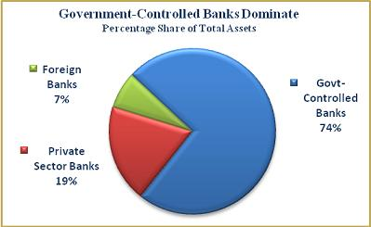

The Public Sector Banks (PSBs), which are the base of the Banking sector in India account for more than 78 per cent of the total banking industry assets. Unfortunately they are burdened with excessive Non Performing assets (NPAs), massive manpower and lack of modern technology. On the other hand the Private Sector Banks are making tremendous progress. They are leaders in Internet banking, mobile banking, phone banking, ATMs. As far as foreign banks are concerned they are likely to succeed in the Indian Banking Industry.

In the Indian Banking Industry some of the Private Sector Banks operating are IDBI Bank, ING Vyasa Bank, SBI Commercial and International Bank Ltd, Bank of Rajasthan Ltd. and banks from the Public Sector include Punjab National bank, Vijaya Bank, UCO Bank, Oriental Bank, Allahabad Bank among others. ANZ Grindlays Bank, ABN-AMRO Bank, American Express Bank Ltd, Citibank are some of the foreign banks operating in the Indian Banking Industry.

As far as the present scenario is concerned the Banking Industry in India is going through a transitional phase. The first phase of financial reforms resulted in the nationalization of 14 major banks in 1969 and resulted in a shift from Class banking to Mass banking. This in turn resulted in a significant growth in the geographical coverage of banks. Every bank had to earmark a minimum percentage of their loan portfolio to sectors identified as “priority sectors”. The manufacturing sector also grew during the 1970s in protected environs and the banking sector was a critical source. The next wave of reforms saw the nationalization of 6 more commercial banks in 1980. Since then the number of scheduled commercial banks increased four-fold and the number of bank branches increased eight-fold.

After the second phase of financial sector reforms and liberalization of the sector in the early nineties, the Public Sector Banks (PSB) s found it extremely difficult to compete with the new private sector banks and the foreign banks. The new private sector banks first made their appearance after the guidelines permitting them were issued in January 1993. Eight new private sector banks are presently in operation. These banks due to their late start have access to state-of-the-art technology, which in turn helps them to save on manpower costs and provide better services.

During the year 2000, the State Bank of India (SBI) and its 7 associates accounted for a 25 percent share in deposits and 28.1 percent share in credit. The 20 nationalized banks accounted for 53.2 percent of the deposits and 47.5 percent of credit during the same period. The share of foreign banks (numbering 42), regional rural banks and other scheduled commercial banks accounted for 5.7 percent, 3.9 percent and 12.2 percent respectively in deposits and 8.41 percent, 3.14 percent and 12.85 percent respectively in credit during the year 2000.

**Current Scenario:**

The industry is currently in a transition phase. On the one hand, the PSBs, which are the mainstay of the Indian Banking system are in the process of shedding their flab in terms of excessive manpower, excessive non Performing Assets (Npas) and excessive governmental equity, while on the other hand the private sector banks are consolidating themselves through mergers and acquisitions. PSBs, which currently account for more than 78 percent of total banking industry assets are saddled with NPAs (a mind-boggling Rs 830 billion in 2000), falling revenues from traditional sources, lack of modern technology and a massive workforce while the new private sector banks are forging ahead and rewriting the traditional banking business model by way of their sheer innovation and service. The PSBs are of course currently working out challenging strategies even as 20 percent of their massive employee strength has dwindled in the wake of the successful Voluntary Retirement Schemes (VRS) schemes.

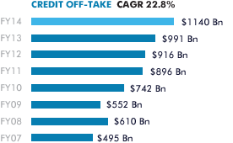

**1.2.5 Aggregate Performance of the Banking Industry:**

Aggregate deposits of scheduled commercial banks increased at a compounded annual average growth rate (CAGR) of 17.8 percent during 1969-99, while bank credit expanded at a CAGR of 16.3 percent per annum. Banks‟ investments in government and other approved securities recorded a CAGR of 18.8 percent per annum during the same period.

In FY01 the economic slowdown resulted in a Gross Domestic Product (GDP) growth of only 6.0 percent as against the previous year’s 6.4 percent. The WPI Index (a measure of inflation) increased by 7.1 percent as against 3.3 percent in FY00. Similarly, money supply (M3) grew by around 16.2 percent as against 14.6 percent a year ago. The growth in aggregate deposits of the scheduled commercial banks at 15.4percent in FY01 percent was lower than that of 19.3 percent in the previous year, while the growth in credit by SCBs slowed down to 15.6 percent in FY01 against 23 percent a year ago. The industrial slowdown also affected the earnings of listed banks. The net profits of 20 listed banks dropped by 34.43 percent in the quarter ended March 2001. Net profits grew by 40.75 percent in the first quarter of 2000-2001, but dropped to 4.56 percent in the fourth quarter of 2000-2001.

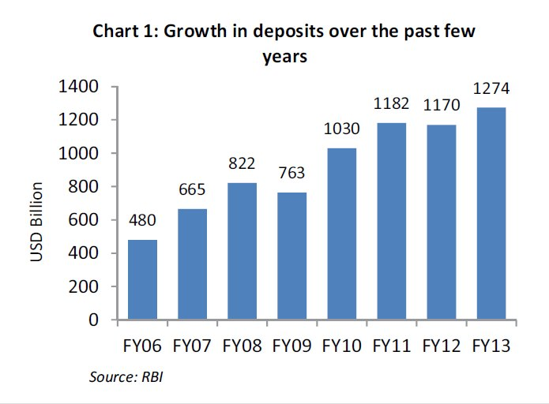

On the Capital Adequacy Ratio (CAR) front while most banks managed to full fill the norms, it was a feat achieved with its own share of difficulties. The CAR, which at present is 9.0 percent, is likely to be hiked to 12.0 percent by the year 2004 based on the Basle Committee recommendations. Any bank that wishes to grow its assets needs to also shore up its capital at the same time so that its capital as a percentage of the risk-weighted assets is maintained at the stipulated rate. While the IPO route was a much-fancied one in the early „90s, the current scenario doesn’t look too attractive for bank majors. Consequently, banks have been forced to explore other avenues to shore up their capital base. While some are wooing foreign partners to add to the capital others are employing the M& A route. Many are also going in for right issues at prices considerably lower than the market prices to woo the investors.

**Users of Banking Services:**

The emerging trends in the level of expectation affect the formulation of marketing mix. Innovative efforts become essential the moment it finds a change in the level of expectations. There are two types of customers using the services of banks, such as general customers and the industrial customers.

**General Users:**

Persons having an account in the bank and using the banking facilities at the terms and conditions fixed by a bank are known as general users of the banking services. Generally, they are the users having small sized and less frequent transactions or availing very limited services of banks.

**Industrial Users:**

The industrialists, entrepreneurs having an account in the bank and using credit facilities and other services for their numerous operations like establishments and expansion, mergers, acquisitions etc. of their businesses are known as industrial users. Generally, they are found a few but large sized customers.

**Bank Marketing Mix and Strategies**:

The first task before the public sector commercial Banks is to formulate that Bank marketing mix which suits the national socio-economic requirements. Some have 4 P's and some have 7 P's of marketing mix. The common four Ps of Marketing mix are as follows:-

**Product**:

To be more specific the peripheral services need frequent innovations, since this would be helpful in excelling competition. The product portfolio designing is found significant to maintain the commercial viability of the public sector banks. The banks professionals need to assign due weightage to their physical properties. They are supposed to look smart active and attractive.

**Price:**

Price is a critical and important factor of bank marketing mix due numerous players in the industry. Most consumers will only be prepared to invest their money in search of extraordinary or higher returns. They are ready to pay additional value if there is a perception of extra product value. This value may be improved performance, function, services, reliability, and promptness for problem solving and of course, higher rate of return

**Promotion**:

Bank Marketing is actually is the marketing of reliability and faith of the people. It is the responsibility of the banking industry to take people in favour through Word of mouth publicity, reliability showing through long years of establishment and other services.

**Place**:

The choice of where and when to make a product available will have significant impacts on the customers. Customers often need to avail banking services fast for this they require the bank branches near to their official area or the place of easy access.

**1.2.6 Bank Marketing Strategies**

The marketing research considered being a systematic gathering, recording and analysis of data makes ways for making and innovation the marketing decisions. The information collected from the external sources by conducting surveys helps bank professional in different wants.

In the bank services, the formulation of overall marketing strategies is considered significant with the view point of tapping the potentials, expanding the business and increasing the marketing share. The increasing domination and gaining popularity banks, the popularity banks, the profitable schemes of the non-banking organization mounting craze among the customers for private banks have made the task of influencing the impulse of customers a bit difficult. The marketing research simplifies the task of studying the magnitude of competition by opinion surveys and the feedback customers, the multidimensional changes in the services mix can be made productive if it is based on marketing research.

**1.3 COMPANY PROFILE**

Ayruz web holdings, is a digital marketing firm located in Techno Park, Trivandrum. It works on disruptive technology solutions which will change the way businesses use the internet to establish a strong identity online and converting visitors to customers. Their expertise in digital marketing and digital media are unmatched by anyone in the market today. The founding team have been using the internet from the time it was launched in Kerala have been a part of its explosive growth. Established in 2009, the young start up has evolved and the team behind Ayruz web holdings have successfully helped more than 100 businesses in the past 5 years to better utilize their digital presence for sales and marketing.

**1.3.1 Objective**

The main objective is “To provide services and develop solutions that help business get online and use internet as a marketing medium”.

**1.3.2 Products**

* The firm also has the following products in the market apart from its competitive services.   
    
  **WordZo** - This is the flagship platform of the company which allows anyone to read books online and enrich their vocabulary easily. The platform is currently in its beta stage and is expected to launch soon.

**Amvizone** - Movie marketing division of ayruz which helps film makers promote their film online and reach out to the online audience. The division has already created high standards in the industry by promoting more than 10 movies including Neelathamara, Kerala Cafe, Janakan and others.

**MetroGeometry** - This is a collection of blogs for cities which provide updates to its readers on events, parties and fun news about the city. The project currently is live in Kochi, Trivandrum, Calicut and Thrissur and is en route to cover all of Kerala by the end of June 2010.

**1.2.3 Services**

The company provide services and develop solutions that help the business get online and use internet as a marketing medium.

**Digital Marketing**

The company help businesses create strategies to sell their products and services online. Using their expertise of more than 7 years online, they help your business take off online and generate revenue online.

**Social Media Consultancy**

Social media is generally considered the best thing after the toaster by many. The company’s creative and practical social media services will help the business establish a presence in various social networks where the audience hang out.

**Search Engine Optimization**

Search Engines are one of the best sources for targeted traffic for any website. Without traffic, the website is virtually invisible to the world. They follow our in-house documented and proven processes to gain listings in search engines organically.

**Search Marketing**

They manage your online advertising using services like Google Adwords TM, Adcenter TM and Yahoo! to gain target visitors to their website. The packages include Keyword Research, Ad Copywriting and landing page optimization which will ensure that the campaigns get the highest conversions.

**Web Application Development**

From enterprise solutions to small scale web applications, they develop applications for any requirement.

**Web Design and User Experience Engineering**

The company’s expertise in web applications is vast and we use this to create design for web application. This will ensure that the website has the right elements of success from a user's viewpoint and reduce design malfunctions.

**1.3.4 Clients**



**1.4 Objectives and Scope of the Study**

**1.4.1 Objectives of the study**

**Primary objective**

* To analyse the customers perception towards internet banking in Kerala

**Secondary objective**

* To explore the factors that affect customer perception towards internet banking.
* To examine whether there is any relationship with the demographic variable and respondent’s perception about internet banking.
* To examine whether the user and non user perception differs.
* To study the problems faced by customers while using internet banking
* To measure the satisfaction level of people towards internet banking.

**1.4.2 Scope of the study**

Nowadays, internet banking has become a necessity and forms a part of life. Therefore, there is a significant scope to examine the factors influence the use of internet banking in Kerala. The study is restricted to state of Kerala. Traditional branch based retail banking remains the most wide spread method for banking transaction. However the internet technology rapidly changing the way of designing and delivering the personal services. Now Commercial banking are introduced internet based e-banking system to improve their operations and to reduce the cost. Despite all their efforts aimed at developing better and easier internet banking system, these systems remain unnoticed by the customer. Advertisers and marketers have been trying to understand the customer perception towards internet banking. This study tries to analyze the factors which influence the use of internet banking in Kerala. The scope of this research has a very good future. Therefore there is a need to understand users’ acceptance of internet banking and a need to identify the factors that can affect their intention to use the Internet Banking.

**1.5 Limitations of the Study**

* Since convenience sampling technique is used in the study, the samples are taken according to the convenient accessibility and proximity to the researcher
* There may be sampling bias and that the sample is not representative of the entire population
* There is limitation in generalization and inference making about the entire population. Since the sample is not representative of the population, the results of the study may often be able to not speak for the entire population.
* The questionnaire employed is an online questionnaire and the lack of a trained interviewer to clarify and probe can possibly lead to less reliable data
* Most of the respondents seemed to be very busy with their jobs and they are not interested in answering the questionnaire
* Lack of time is yet another limitation

**1.6 Chapterisation.**

**Chapter I**

This deals with introduction includes background of the study, industry profile, company profile, scope and objective of the study and chapterisation

**Chapter II**

This chapter includes the literature review. This also contains earlier researches done on loans and advances, credit risk, non- performing assets and customer satisfaction.

**Chapter III**

The main content of this chapter is research methodology. This chapter includes objectives, research design, period of study, duration of study, sources of data, tools of data, collecting statistical analysis, hypothesis, and limitation of study.

**Chapter IV**

This contains the data analysis and interpretation and a questionnaire analysis of a customer perception towards equity market is done.

**Chapter V**

This deals with the findings and suggestions of the study.

**CHAPTER 2**

**LITERATURE REVIEW**

**2 LITERATURE REVIEW**

2.1 **CONSUMER BEHAVIOUR**

According to Warner, consumer behavior defines that **“the study of the mental and physical activities performed by individuals or groups that result in decisions or actions associated with the purchase, use or disposal of goods and services”** **(Malcolm).** Warner emphasized the consumption related behaviors are often undertaken collectively. For example, some activities performed by individuals but consumed by a family or group of people, similar as organization purchasing activities usually followed by group decisions.

Consumer behaviour has been always of great interest to marketers. The knowledge of consumer behaviour helps the marketer to understand how consumers think, feel and select from alternatives like products, brands and the like and how the consumers are influenced by their environment, the reference groups, family, and salespersons and so on. A consumer’s buying behavior is influenced by cultural, social, personal and psychological factors. Most of these factors are uncontrollable and beyond the hands of marketers but they have to be considered while trying to understand the complex behavior of the consumers.

Consumer is the study “of the processes involved when individuals or groups select, purchase, use, or dispose of products, services, ideas, or experiences to satisfy needs and desires” **(Solomon 1995, 7)**. In the marketing context, the term consumer ‟ refers not only to the act of purchase itself, but also to patterns of aggregate buying which include pre-purchase and post-purchase activities. Pre-purchase activity might consist of the growing awareness of a need or want, and a search for and evaluation of information about the products and brands that might satisfy it. Post-purchase activities include the evaluation of the purchased item in use and the reduction of any anxiety which accompanies the purchase of expensive and infrequently-bought items. Each of these has implications for purchase and repurchase and they are amenable in differing degrees to marketer influence **(Foxall 1987)**.

**2.2 CONSUMER PERCEPTION**

The topic consumer perception and frequency of usage basically come from consumer behaviour. The purpose of the present study is to provide an over view of existing research work about consumer behavior and perception about internet banking. Consumer behavior is the study of why, when, and how. Consumer behavior is that rational behavior that consumer shows toward products while buying. Consumer behavior is the mixture of psychological, social, economical, and social anthropological situations and environment. Perception is how human recognize and interpret stimuli **(SITTER, 2008)**. Consumers’ perception of quality is measured an essential determinant of product choice **(Zenithal, 1988)**. In other words perception is the first impression that individual draw and on the basis of it select, and interpret information to form a meaningful picture of the world **(MUNNUKKA, 2008).** That’s why it is believed that consumer perception influence customer level of satisfaction and so their buying and usage decisions.

Consumer preferences of product attribute is different according to product nature as well as its Social and economic nature of consumer **(Uusitalo, 2001).** Product attributes are often eye-catching in nature **(Vishwanathan and Childers, 1999)**. The attributes model proposed by **Gwin and Gwin (2003)** posits that consumer preference of product is based on maximizing utility from the product features subject to financial shortage. Choice theory defines that consumer preference based on product features.

The perception is the formed as a result of interpreting the experience. There is a growing interest in understanding the users’ experience **(Hiltunen et al., 2002)**; as it is observed as a larger concept than user satisfaction. From this perspective, assessing the user experience is essential for many technology products and services **(Wilson & Sasse, 2004)**.

Customers have started perceiving the services of bank through internet as a prime attractive feature than any other prime product features of the bank. Customers have started evaluating the banks based on the convenience and comforts it provides to them. Bankers have started developing various product features and services using internet applications

**2.3 INTERNET CONSUMERS**

Online consumers differ from the general population in one important respect: they own or have access to a computer **(Berkowitz, Kerin, Hartley, and Rudelius, 2000).** New markets, new technologies and new products have all arisen together, creating opportunities for those new types of consumer behavior, which cannot be analyzed profitably by the old marketing disciplines.

Internet shoppers are more convenience-seekers, innovative, impulsive, variety seekers, and less risk-averse than Internet non-shoppers are. Internet shoppers are also less brand and price conscious than Internet non-shoppers are. Internet shoppers have a more positive attitude toward advertising and direct marketing than non-shoppers do. However, not all Internet/Web users use the technology the same way, nor are they all likely to be online buyers. This means Web users are not the same in their Web use behavior.SRI International **(Berkowitz, Kerin, Hartley, and Rudelius, 2000)** identifies ten distinct Internet/Web user profiles, called iVALS, which illustrate how diverse Internet/Web users can be, and based on two dimensions: how heavily and enthusiastically they use the Internet;

**2.4 INTERNET BANKING**

Technology has revamped entire business scenario all around the world. In this reference e-banking has emerged out to be a boon for ensuring smooth and quicker flow of funds. It has transformed and revolutionized the traditional banking industry **(Mols, 2000)**. As per prediction of Broad the e- banking is leading to a paradigm shift in marketing practices resulting in high performance in the banking industry. Delivery of service in banking can be provided efficiently only when the back ground operations are efficient. An efficient back ground operation can be conducted only when it is integrated by an electronic system. The components like data, hardware, software, network and people are the essential elements of the system. Banking customers get satisfied with the system when it provides them maximum convenience and comfort while transacting with the bank. Internet enabled electronic system facilitate the operation to fetch these result. Nowadays the Internet is the main channel for electronic banking. Internet banking is one of the most popular B2C ecommerce activities **(Eastin, 2002).** Developing countries, such as India, have also reported increasing diffusion of internet banking in the past few years **(Malhotra and Singh, 2010).**

Internet banking is the term used for new age banking system. Internet banking is also called as online banking and it is an outgrowth of PC banking. Internet banking uses the internet as the delivery channel by which to conduct banking activity, for example, transferring funds, paying bills, viewing checking and savings account balances, paying mortgages and purchasing financial instruments and certificates of deposits **(Haque et al, 2009).** Internet banking is a result of explored possibility to use internet application in one of the various domains of commerce. It is difficult to infer whether the internet tool has been applied for convenience of bankers or for the customers’ convenience. But ultimately it contributes in increasing the efficiency of the banking operation as well providing more convenience to customers. Without even interacting with the bankers, customers transact from one corner of the country to another corner. Customer’s transaction and communication abilities have being faster by the developments of information technology **Giannakoudi, S. (1999).** In the early 70s, the banking sector distribution channel started its revolution in information technology, with credit card, the Automatic Teller Machine (ATM) and the ATM networks being unveiled. After which the telephone banking, cable television banking came into existence in the 80s, and the progress of Personal Computer (PC) banking in the late 80s and in the early 90s **Giannakoudi, S. (1999).**

Information technology enabled electronic channels to perform many banking functions that would traditionally be carried out over the counter **Giannakoudi, S. (1999).** The rise of electronic payments media such as debit and credit cards has caused the value of checks paid in the United States to fall to from about $49billion in 1995 to about $42 billion in 2002 **Gerdes et.al.(2002)**. Furthermore, the use of paper cheque is being supplemented step by step with electronic images, allowing the storage capacity to be high, reducing costs and improving customer services **Rose et.al (2005)**. Internet banking offers many benefits to banks and their customers **(Karjaluoto, 2002).** The main benefits to banks are cost savings, reaching new segments of the population, efficiency, enhancement of the bank’s reputation and better customer service and satisfaction **(Jayawardhena and Foley, 2000)**. To customers Internet banking offers also new value. With the help of the Internet, banking is no longer bound to time or geography.

In fact internet banking is such an internet portal through which customers may use vivid range of banking services from bill payment to making investments **(Pikkarainen, Karjaluoto, and Pahnila, 2004)**. It provides number of services to its users and access to almost any type of banking transaction (except cash withdrawal) at the click of a mouse **(Young, 2001)**. **Flavián, Torres, & Guinalíu, (2004)** argued that use of internet as an alternative channel for financial services has now become a competitive necessity instead of being simply a competitive advantage. **Lustsik (2003)** pointed out that offering of e-banking services facilitates better branding and responsiveness to the bank Consumers all over the world have relatively easy access to their accounts 24 hours per day, seven days a week. It makes available to customers a full range of services including some services not offered at branches. Internet banking has the advantage that the customer avoids travelling to and from a bank branch. In this way, Internet banking saves time and money provides convenience and accessibility **(Karjauloto, 2003).** Customers can manage their banking affairs when they want, and they can enjoy more privacy while interacting with their bank. It has been claimed that Internet banking offers the customer more benefits at lower costs **(Mols, 1998)**. **Turban et al. (2000)** indicated that Internet banking is extremely beneficial to customers because of the savings in costs, time and space it offers, its quick response to complaints, and its delivery of improved services, all of which benefits make for easier banking.

It is convenient, it isn’t bound by operational timings, there are no geographical barriers and the services can be offered at a minuscule cost **(IAMAI’s, 2006).** An in-depth analysis would help to understand that internet enabled electronic bank system differentiates from traditional banking operation through faster delivery of information from the customer and service provider. Additionally, it has to be noted that the banking operations does not transfer physical currencies instead it transfer the information about the value for currencies. I-banks enable transfer of information more swiftly on-line. **(Salawu et.al, 2007)**. Electronic banking has experienced explosive growth and has transformed traditional practices in banking **(Gonzalez et al., 2008).** Banking Journey In 2001, In Reserve Bank of India survey revealed that of 46 major banks operating in India, around 50% were either offering Internet banking services at various levels or planned to in the near future. According to are search report,( India Research, Kotak Securities, May 2000.) while in 2001, India’s Internet user base was an estimated 9 lakhs; it was expected to reach 90 lakhs by 2003.Also, while only 1% of these Internet users utilized the Internet banking services in 1998,the Internet banking user base increased to 16.7% by mid- 2000.According to **Sana Haider Sumra (2011)**, the main motive for e-banking identified by the all bank managers was their customers, to amplify their clientage, to increase customer satisfaction, retention and business expansion which would eventually gain them more profits. Managers have shown a positive attitude towards e-banking; they have concluded that e-banking is enhancing profitability and financial positions of banks and banks are striving hard to provide more and more services to their customers and to move towards advance and modern e-banking services also developing infrastructure. They revealed that till 2013 banks will completely adopt e-banking and it all dimensions.

**Harris (2007)** observed that Internet Banking is Becoming "Need to Have" service. E-banking is one of the most recent technological innovations, which is becoming a need for every common man. It uses Internet as a medium for delivery banking services. Today, banking is not limited to branches, where a person goes to bank for withdrawal of cash or request a statement of accounts or to deposit a check. An inquiry or transaction can be handled online without any reference to the branch any time through Internet Banking. Benefits of internet banking include fast speed, convenient, cost effective, all time accessibility, and flexibility.

**2.5 INTERNET BANKING ADOPTION**

One advantage of banks going online is the potential savings in the cost of maintaining a traditional branch network **(Shih and Fang, 2004)**. **Turban et al. (2000)** indicated that Internet banking is extremely beneficial to customers because of the savings in costs, time and space it offers, its quick response to complaints, and its delivery of improved services, all of which benefits make for easier banking. Online banking acceptance has gained special attention in academic studies during the past five years as, for instance, banking journals have devoted special issues on the topic. The Technology Acceptance Model, TAM **(Davis, Bagozzi, & Warshaw, 1989)**, has become the bona fide model of IT acceptance, forecasting the extent to which a new IT is used. The basic premise in TAM is that two behavioral outcome beliefs about a new IT, namely its perceived usefulness (PU) and its perceived ease of use (PEOU), are significant predictors of its intended future use.

**Suh and Han (2002)** conducted an investigation based on the technology acceptance model (TAM) to analyze customer acceptance of Internet banking. They claimed TAM as an appropriate model for explaining acceptance in the context of Internet banking. TAM is based on Fishbein and Ajzen's theory of reasoned action (TRA) **(Davis et al., 1989)** and is a general model that assumes that individual social behavior is motivated by behavioural attitudes. **Sohail and Shanmugham (2003)** examined the factors that influence the adoption of Internet banking and investigated whether Internet users and others differed in terms of these factors. Research into customer acceptance of Internet banking has thus improved understanding of what beliefs lead customers to use the facility and demonstrate how the beliefs influence Internet bank customer behavior **(Shih and Fang, 2004). Suh and Han (2002)** conducted an investigation based on the technology acceptance model (TAM) to analyze customer acceptance of Internet banking.

**2.6 THEORETICAL MODEL EXPLANATION**

Generally, a study of adoption of information technology takes one of three possible approaches, a diffusion approach, an adoption approach or a domestication approach **(Vijayan, Perumal and Shanmugam, 2004)***.* Diffusion researchers typically describe the aggregate acceptance process as a function of time that may be used to categorize users of different kinds **(Mahajan, Muller and Bass, 1990)**. Others like, **Rogers (1995)** describe the diffusionprocess as consisting of four elements: an innovation or new technology, a social system, the communication channels of the social system and time. Adoption researchers, on the other hand, typically describe and explain the acceptance decision of individual users applying different social theories of decision-making. The theory is as follows:

**2.6.1 Technology Acceptance Model (TAM)**

The Technology Acceptance Model (TAM) has formed the foundation of many studies of information systems **(Bahmanziari, 2003; Pavlou, 2003).** Technology Acceptance Model (TAM) originally proposed by **Davis (1989).** TAM proposed two measurable variables for technology acceptance, i.e. perceived usefulness and perceived ease of use. Perceived usefulness explains the user's perception to the extent that the system will improve the user's workplace performance; perceived ease of use explains the user's perception of the amount of effort required to utilize the system or the extent to which a user believes that using a particular system will be effortless **(Davis et al., 1989).** Since its introduction by **Davis (1989)** **and Davis et al**. **(1989),** TAM has been widely employed by researchers to explain user acceptance of technology **(Ng, 2003; Bahmanziari, Pearson & Crosby, 2003; Pavlou, 2003).**

Although TAM was designed to predict user adoption of information technology applications in the organizational workplace **(Riemenschneider, Hardgrave & Davis, 2002),** researchers have modified the original model to explain electronic commerce acceptance **(Dahlberg, Mallat & Oorni, 2003; Featherman & Pavlou, 2002)**. The enhanced models of TAM with specific variables for electronic commerce applications, hence serve as the basis of this review.TAM has been tested in many studies **(Davis, 1989; Taylor and Todd, 1995)**, and it has been found that TAM's ability to explain attitude toward using an information system is better than other model's (TRA and TPB) **(Mathieson, 1991).** These studies have found that TAM consistently explains a significant amount of the variance (typically around 40 percent) in usage intentions and behaviour. The use of an information system has been understood in many studies as the user acceptance of the information system in question **(Davis et al., 1989).** In other words the use of information system acts as an indicator for information system's acceptance.

Accordingly**, Liao and Cheung (2002)** presented empirical estimates to predict the marginal effects of the factors underlying perceived usefulness and willingness to use, and the substitutability between them. Their data demonstrated that the key quality attributes underlying perceived usefulness were expectations of accuracy, security, network speed, user friendliness, user involvement and convenience.

**Beliefs > Attitude > Intention> Behaviour**

Based on certain beliefs, a person forms an attitude about certain objects, on the basis of which one forms an intention as to how one should behave with respect to that object. The intention to behave is the sole determinant of actual behaviour **(Vijayan, Perumal and Shanmugam, 2005).** Davis adapted the TRA by developing two key beliefs that specially account for information system usage. The first of these beliefs is perceived usefulness, defined as the 'degree to which a person believes that using a particular system would enhance his/her job performance' **(Davis, 1989)**. The second is perceived ease of use, defined as 'the degree to which a person believes that using a particular system would be free of effort' **(Davis, 1989).** A diagram of the model is presented in Figure 1.



**2.6.2 Applicability of TAM to study user acceptance of Internet Banking**

TAM has been widely used as a framework for surveys where existing products are assessed. **Davis and Venkatesh (2004)** proved out that stable and behaviourally predictive measures of perceived usefulness of information systems can be made by using mock-ups. Traditionally, mock-ups are used in human-centred design to evaluate proposed designs with users for ease of use. **Davis and Venkatesh (2004)** suggest that mock-ups should increasingly be used to assess the usefulness of the proposed system at a pre-prototype phase of the project. The Technology Acceptance Model constitutes a solid framework to identify issues that may affect user acceptance of technical solutions. As **Davis and Venkatesh (2004)** have proved, the model can be enhanced from the original purpose of studying user acceptance of existing products to study planned product concepts e.g. in the form of mock-ups. This indicates that TAM could also be used in connection with technology development projects and processes to assess the usefulness of proposed solutions. Applied in this way, the mode also supports the human-centred design approach. **Legris et al. (2003)** have made a review of published studies on the applications of TAM, and made a wider analysis of 22 studies. They identified three significant limits in TAM research: the narrow focus of the applications with the main emphasis on office automation, narrow user groups with many studies made with students as users, and measurements based on self-reported use rather than observing actual usage. By applying TAM in connection with field trials, user acceptance can be studied with real users and actual usage situations.

**2.7 INTERNET BANKING SERVICES**

**Vardhman (2007)** said Online Banking - The Need of the Modern Professional- Internet Banking has been so popular in the countries it has been implemented in so far due to certain reasons. Online Banking makes the regular transactions for a client speedy and time efficient with little or no paperwork involved. There is no need for standing in long queue any more for making a deposit or getting a withdrawal. Banking has turned into a 24/7 service with the bank always available to their client. **Kesseven (2007)** said that the mostly used E-Banking services are inter account transfer, payment to other personal account, transfer to credit card account, recharge mobile phones among others.

Comparing demographic variables of the internet banking users to the non- internet banking users, the analysis reveals that there is no significant difference between the two group of users with respect to age group and the education level of the respondents. **Srinivasan (2007)** investigated that in specified region of Karnataka, channel convenience, channel control and channel security plays an important role in the selection of channels. Some regions still see people who are struck to branch banking and are not ready for a change in mindset. Across Telebanking was not popular since it was not perceived as a safe and convenient channel. **Sayar et. All (2007)** discussed that the developments in information technology and the subsequent evolution of internet banking have fundamentally changed the ways in which banks implement their business and consumers conduct their everyday banking activities. The results confirm the influence of internet trust on risk perception and consumer attitudes towards internet banking. .

The results confirm the influence of internet trust on risk perception and consumer attitudes towards internet banking. Propensity to trust is a determinant not only for interpersonal relationships but also for trust in technological systems. This is not a representative study. **Kamiya (2006)** investigated how e- banking can ease your life. Internet banking provides us facilities like Bill payment service, fund transfer, credit card customers, railway passing, Investing through internet banking, recharging your prepaid phone, shopping at your fingertips. Indian banks are trying to make your life easier. Not just bill payment, you can make investments, shop or buy tickets and plan a holiday at your fingertips. Srivastva (2006) found that ; (1) perceived risk with online shopping, (2) past experience with online shopping, (3) perceived benefits of online shopping, (4) perceived ease of online shopping, and (5) perceived\ uncertainty of online shopping are the factors that affect the customer perception regarding E-banking.

**Riquelme (2006)** investigated that the majority of customers in the sample are satisfied or very satisfied with the service and online systems attributes. The investigation does not support previous findings that more satisfied customers tend to use more products and services or that using internet banking for a longer period is associated with higher levels of satisfaction. It appears that companies that offer a wide product portfolio and relevant website content accompanied by prompt and courteous response create satisfaction online. **Black et.all (2001)** conducted the study to know; what are the customer's perceptions about internet banking and what the drivers that drive consumers are. How consumers have accepted internet banking and how to improve the usage rate were the focus of research area in this study. Qualitative exploratory research using questionnaire was applied. 500 respondents were selected for study after initial screening. They were all bank customers. The study revealed that education, gender, income plays an important role in usage of internet banking. .

The research corroborated the conceptual framework stating that if skills can be upgraded there will be greater will to use internet banking by consumers. **Nachiket (2000)** found that that Reserve Bank of India survey revealed that of 46 major banks operating in India, around 50% were either offering Internet banking services at various levels or planned to in the near future.

According to a research report**,( India Research, Kotak Securities, May 2000.)** while in 2001, India's Internet user base was an estimated 9 lakh; it was expected to reach 90 lakh by 2003. Also, while only 1% of these Internet users utilized the internet banking services in 1998, the Internet banking user base increased to 16.7% by mid- 2000. **Meuter et.al (2000)** found that customers distinguish the quality of customer interactions that take place during service delivery and the quality of the outcome the customer receives in the service encounter.

**2.8 FACTORS AFFECTING CUSTOMER PERCEPTION TOWARDS INTERNET BANKING**

Customers perceive the quality of services of Internet banking based on the performance of online delivery systems – not on the processes in which the delivered service is developed and produced. Because customers perceive Internet banking service quality based on relatively standardized outcomes determined by online systems.

**Mishra (2005)** in his paper explained the advantages and the security concerns about internet banking. According to him, improved customer access, offering of more services, increased customer loyalty, attracting new customers are the primary drivers of internet banking. But in a survey conducted by the online banking association, member institutions rated security as the most important concern of online banking. Recent research has indicated that “trust” has a striking influence on user willingness to engage in online exchanges of money and personal sensitive information **(Friedman et al., 2000).** According to **Davis (1989)** noted that technology acceptance research must address how other variables affect usefulness, ease of use and user acceptance. Therefore, perceived ease of use and perceived usefulness may not fully explain behaviour intentions towards the use of internet banking, necessitating a search for additional factors that can better predict the acceptance of internet banking.

There is an availability of number of researches to display different factors that motivate customers to adopt e-banking as their primary media for banking. **Joseph et al. (2003)** found that reliability, accuracy, personalized and better customer services are some of the factors that are considered by the customers before opting any service delivery channel. Some researchers recognized convenience, flexibility, security concern, complexity, and responsiveness as some of the prominent determinants of e-banking modishness at global level **(Barczak et al., 1997; Danniel & Strong, 1997; Lia et al., 1999; Polatoglu & Ekin, 2001; Devlin & Yeung, 2003).**

**Demographic Factor**

It has been widely recognised that demographic factors have a great impact on consumer attitudes and behaviour regarding online banking **(Sathye, 1999; Karjaluoto et al., 2002).** Researcher analysis if there is any significant difference between age, gender and income and towards Internet Banking Intention. We further conjecture that satisfaction with internet banking is likely to be influenced by the demographic profile of customers. Our assertion is rooted in the findings of the contemporary e-business and IT literature which suggest that end-users’ satisfaction with internet-enabled IT systems (such as various forms of B2C and B2E applications) is affected by demographic factors. Our belief is also consistent with the views of the diffusion of innovation (DOI) researchers. **Rogers ( 1985)** who suggest that demographic variables often affects the uptake of new innovations. It is thus important to evaluate the influence of demographic factors in relation to internet banking in order to find out how various constructs that comprise customer satisfaction are affected by those factors. We believe that the intention of customers (who are initial adopters) to continue to use internet banking could be seriously affected when internet banking fails to satisfy their changing requirements. According to **David (2007),** culture is known to have an impact on customers’ behaviour and satisfaction. As a result, it is essential to determine the current level of customer satisfaction with internet banking and address how various demographic factors affect customer satisfaction.

**Gender**

The IS literature is full on the various gender-based studies and researchers have studied the variable from various dimensions. There is a debate concerning the impact of gender on the study of attitudes towards computer use and it was found that males had positive computer attitudes as compared to female towards computer use **(Key, 1992; Bell, 1995, Seyal et al. 2000)**. **Shashaani, (1997)** found that men tend to be more interested in computers than women on average contributing to gender difference in Internet use. **Gefen and Straub, (1997)** and **Venkatesh and Morris, (2000)** found gender difference in individual adoption and sustained usage of technology in the work place. **Teo and Lim (2000) and Teo (2001)** found that males tend to use more internet activities as compared to female.

**Ono and Zavodny (2002)** found that women were significantly less likely to use the Internet than men at home or elsewhere. **Dahlan et al. (2002)** in their study of Malaysian bank employees found males were more ready in data mining as compared to female employees. **Ramayah and Jantan (2004)** found males exhibit higher use of the Internet in messaging, browsing and downloading activities. However, **Awamleh and Fernandes (2005)** did not support gender differences among Internet banking customers’ satisfaction study in UAE.

**Age**

Age is considered a significant variable among various IS adoption studies in studying the attitudes towards computers **(Kay, 1992)** and the Internet **(Mukherjee and Nath, 2003).**

However, in the various studies it has produced varying results. According to the 1998 Household Internet Use Survey (The Daily, 1999) in Canada the age group 35–54 were most likely to use the Internet followed by the under 35 years of the age. **Krut et al. (1998)** found that age, gender and race were positively associated with technology usage. **Teo (2001)** supported age as a crucial factor in Internet adoption. However, **Ramayah and Jantan (2004)** found that age is negatively associated with the students’ use of the Internet.

**Income**

Several previous studies in Information Systems studied the impact of income as one of the factors associated with the use of computers and the Internet. **Teo (2001)** found that income level was a significant factor in Internet use. **Awamleh and Fernendes (2005)** noticed income appeared to be a significant factor in transaction security among customers’ satisfaction.

**Educational Level and occupation**

Several researchers have highlighted the importance of education not only in the formation of positive attitude toward the technology usage but also as a factor that is significant in the actual usage of Information Technology. **Kay (1992)** has reported that in general, people with higher educational qualifications have a favorable predisposition in regards to computer use. **Al-Jabri et al. (1997) and Seyal et al. (2002)** have found the relationship of educational qualifications with positive attitudes towards the use of the computer. **Mendoza and Toledo (1997)** in their study of demographics and behavior of the Chilean Internet population found a significant relationship between higher education and Internet usage.

**Internet Experience**

Prior experience in both computer and Internet strengthens the individual belief in terms of using subsequent technological innovations such as Internet businesses and Internet banking. **Taylor and Todd (1995)** discovered that experienced users with the similar systems would have higher intention to use the system. Whereas, **Venkatesh and Davis, (1996)** suggested the external factors such as computer experience had a direct effect on behavioural components in terms of technology usage. **Black et al. (2001)** found that previous experience with the Internet is one of the strongest influencing factors that affect Internet banking adoption. Similarly, in Malaysia, **Ndubisi et al. (2001) and Ramayah, et al. (2003)** have examined various external factors that affect the technology acceptance and found prior experience with technology is significantly related with the technology adoption.

Technology has revamped entire business scenario all around the world. In this reference e-banking has emerged out to be a boon for ensuring smooth and quicker flow of funds. It has transformed and revolutionized the traditional banking industry **(Mols, 2000).** It is a wonderful media to reduce transaction cost. Further the increased volume of transactions may compensate the fixed cost that a bank may have to bear for providing click bank services. **Wise and Ali (2009)** remarked that the objective to invest in ATMs by Bangladesh banks is to reduce the branch cost. It argued that the marginal increase in fee income could substantially be offset by the cost of significant increment in the number transactions. It empowers banks to deliver variety of value added services to its customers **(Bitner 2001).**

In fact internet banking is such an internet portal through which customers may use vivid range of banking services from bill payment to making investments **(Pikkarainen, Karjaluoto, and Pahnila, 2004)**. It provides number of services to its users and access to almost any type of banking transaction (except cash withdrawal) at the click of a mouse **(Young, 2001).** **Flavián, Torres, & Guinalíu, (2004)** argued that use of internet as an alternative channel for financial services has now become a competitive necessity instead of being simply a competitive advantage. **Lustsik (2003)** pointed out that offering of e-banking services facilitates better branding and responsiveness to the bank.

E-banking has eliminated the boundary of time and geography. Now the customers have relatively easy access to their accounts, 24 hours per day, and seven days a week all round the globe **(Karjaluoto et al. 2002).** The flexible design of e-banking allows customers to make changes while making transactions and further ensures availability of customer service adviser within minimum possible waiting time **(Dabholkar 1994).**

There is an availability of number of researches to display different factors that motivate customers to adopt e-banking as their primary media for banking. **Joseph et al. (2003)** found that reliability, accuracy, personalized and better customer services are some of the factors that are considered by the customers before opting any service delivery channel. Some researchers recognized convenience, flexibility, security concern, complexity, and responsiveness as some of the prominent determinants of e-banking modishness at global level **(Barczak et al., 1997; Danniel & Strong, 1997; Lia et al., 1999; Polatoglu & Ekin, 2001; Devlin & Yeung, 2003). Nupur (2010)** found that the satisfaction level of e-banking users is related with reliability, responsiveness, assurance, empathy, and tangibles.

Some studies identified bank-corporate customer relation as one of the important factor for the success of financial services and having a higher competitive advantage in the market **(Kandampully & Duddy 1999, Easingwood & Storey 1993)**. **Akinyele and Olorunleke (2010)** studied technology and service quality in banking industry in Nigeria. They found that secured services are the most important dimension of e-banking. Similarly another study recognized that security as one of the paramount issue questioned by e-banking users. They found that security issue basically depends upon some factors viz., availability of internet service, social factors and psychological factors **(Mattila and Mattila 2005).**

In the common parlance the study of perceived easiness in using website and the privacy policy found that the most important factor influencing adaptability of e-banking is security. Further the study noticed that perceived ease of use is of less importance than privacy and security **(Hua 2009).** In a study of assessing the impact of e-banking functionality factors over satisfaction, it was found that among all the variables security, privacy, and content appear to have the greatest impact on satisfaction **(Ahmad & Al-Zubi 2011).**

All these studies emphasis upon the need of e-banking in present scenario and also suggest some measures to enhance the propensity to use. But still there is a dearth of studies to study the perception and satisfaction level of rural customer from e-banking.

**Wungwanitehakom(2002)** remarked that if banks are to reap the benefit of internet banking via customers satisfaction with such service, then they must identify how the service is currently being perceived by potential adopters and the characteristics of consumers who adopt it and determine whether there is demand for such services, as well as the factors affecting it. **Dr C. Paramasivan (2009)** in his studies entitled “Customer satisfaction through information technology in commercial banks’ highlighted that, customers are satisfied with banking services to some extent and the bankers should try to improve their services at an affordable cost with the help of information technology.

**According to Gönroos(1982),** customers distinguish the quality of customer interactions that take place during service delivery (functional quality) and the quality of the outcome the customer receives in the service encounter (technical quality).Customers perceive the quality of services of Internet banking based on the performance of online delivery systems – not on the processes in which the delivered service is developed and produced. Because customers perceive Internet banking service quality based on relatively standardized outcomes determined by online systems, customer attitudes toward that outcome reflect overall quality of services delivered Customers usually perceive risks in conducting transactions electronically and particularly if the transactions involve money.

The perception is the formed as a result of interpreting the experience. There is a growing interest in understanding the users’ experience **(Hiltunen et al., 2002 .);** as it is observed as a larger concept than user satisfaction. From this perspective, assessing the user experience is essential for many technology products and services **(Wilson & Sasse, 2004).**

Customers have started perceiving the services of bank through internet as a prime attractive feature than any other prime product features of the bank. Customers have started evaluating the banks based on the convenience and comforts it provides to them. Bankers have started developing various product features and services using internet applications.

**2.9 FRAMEWORK OF THE FACTORS**

As mentioned that survey focuses on the finding the customers’ perception on various internet application related with internet banking. Various factors which contribute to the customers’ perception such as convenience, flexible virtual banking system, reliability, time factor, real time access to information, saving transaction cost, on-line bill payments, digital signature for security, faster transfer, easy to use, user friendly, low transaction fees, anytime and anywhere banking facility, access to current and historical transaction data, facility of fund transfer to third party are taken for this study. These factors came from different studies.

**The Framework of the factors which are taken to assess the perception is as follows:**

* **Convenience way of operating banking transactions**: Online banking is a highly profitable channel for financial institutions. It provides customers convenience and flexibility and can be provided at a lower cost than traditional branch banking **(Williamson, 2006).** The convenience of online banking is helping people gain greater control of their finances and contributing to changing patterns in cash withdrawal and day to day money management **(Beer, 2006).**
* **Flexible virtual banking system**: Financial institutions have spent a great deal of time and money developing online banking functionality to allow customers an easy and convenient way to manage their money **(Williamson, 2006)**. A customer can check balance by logging into banks website through a user name and password. In this way he can enquire balance, status of cheques, perform funds transfers, order drafts, request issue of cheque books etc **( Srivastava,2008).**
* **Reliability**: **Jun and cai (2001)** identified one of the very important service quality dimensions of internet banking service quality is reliability. The online banking environment has grown tremendously over the past several years and will continue to grow as financial institutions continue to strive to allow customers to complete money transfers, pay bills, and access critical information online. During this same time, online banking has been plagued by Internet criminals and fraudsters attempting to steal customer information. Phishing and other types of attacks have become well known and are widely used as a means for fraudsters to obtain information from customers and access online banking accounts. As a result, authenticating customers logging onto their online banking service has become a crucial concern of financial institutions **(Gregory D. Williamson, 2006).**
* **Time factor**: **Liu and Arnett** in their study identified time factor as one of the prime factor that in Internet banking service quality feature for the customers. Saving time is an importance factor which influences the customers prefers to use i-banking. **(Beer, 2006).** Banks can make the information of products and services available on their site, which is, an advantageous proposition. Prospective customer can gather all the information from the website and thus if he comes to the branch with queries it will be very specific and will take less time of employee **(Srivastava, 2006).**
* **Real time access to information**: The banks started i-banking initially with simple functions such as real time access to information about interest rates, checking account balances and computing loan eligibility. Then, the services are extended to online bill payment, transfer of funds between accounts and cash management services for corporate **(Sadique et al, 2009).**
* **Saving transaction cost**: Improving customer service, increasing market reach and reducing costs are now basic expectations of Internet banking services. If consumers are to use new technologies, the technologies must be reasonably priced relative to alternatives. Otherwise, the acceptance of the new technology may not be viable from the standpoint of the consumer **(Suganthi et. al, 2001).** Internet banking model offers advantages for both banks and customers. The Internet provides the banks with the ability to deliver products and services to customers at a cost that is lower than any existing mode of delivery.
* **On-line bill payments**: The most popular online transaction through internet banking is funds transfer/bill payment **(Beer, 2006).** Of the twenty-two million users in US, twenty percent or 4.6 million people regularly used online bill payment services offered by the top ten financial institutions. This report also highlighted that the usage of online bill payment services increased by thirty-seven percent at the end of the first quarter 2004 **(Strasburg, 2005).**
* **Ticket Booking**: Ticket booking is another important feature of internet banking. Now, people need not visit booking reservation centers any more, they can buy air and train tickets online using Internet Banking Facility
* **Security**: In a survey conducted by the Online Banking Association, member institutions rated security as the most important issue of online banking. There is a dual requirement to protect customers’ privacy and protect against fraud (Mishra). Digital signature is a precautionary measure to prevent malpractices and tampering the information. It is a form of enhanced authentication **(Williamson, 2006).** Nearly one in 5 customers was victims of identity theft and fraud **(TriCipher, 2007).**
* **Faster transfer**: Another important factor that contributes the framework of the perception is the faster transfer of fund. The fundamental advantage of the internet banking is the transfer of the information about the money’s worth to any place at any time with a mouse clicks distance.
* **Easy to use and user friendliness**: Ease of use is another important determinant for the customer preferring the internet banking **(Beer, 2006).** In a study conducted by **Cooper (1997);** reported that ease of use of innovative product or service as one of the three important characteristics for adoption from the customer’s perspective. The user friendliness of domain names as well as the navigation tools available in the web-sites is an important determinant for ease of use. The design of the web-sites with appropriate use of graphical user interface is also considered as an important determinant. **(Cooper, 1997)** It is also worth noting that proper navigation attributes and search facility will also certainly be helpful to consumers when they surf the Internet. In addition, the level of interactivity of the site will certainly have an effect on the consumers’ perception of the user friendliness of the Internet **(Suganthi et. al, 2001).**
* **Low transaction fees**: Another factor that would stand in the way of consumer adoption of Internet banking is the cost factor. In Internet banking, two types of costs are involved. First, the normal costs associated with Internet access fees and connection charges and secondly the bank fees and charges **(Suganthi et. al, 2001).** These two types of costs shape the perception of the customers.
* **Anytime and anywhere banking facility**: Online banking users say that convenience is the most important factor, online banking lets them access their accounts from anywhere and at any time **(IAMAI’s, 2006).**
* **Access to current and historical transaction data**: According to IAMAI report’s – online banking ‘2006’, customers prefer to view account balances, transaction history and updates get e-statements, credit card and debit card transaction history and updates, checking the status of their credit card accounts, viewing information regarding their demat account, information on their fixed deposits.
* **Facility of fund transfer to third party**: According to IAMAI report’s – online banking 2006, majority of the customers prefer on-line banking channels to transfer funds to third party.
* **Queue management (Traffic Management)**: One among the important dimensions of e-banking service quality is queue management **(Joseph et al.. 1999).**

**CHAPTER 3**

**RESEARCH METHODOLOGY**

**3 RESEARCH METHODOLOGY**

The system of collecting data for research projects is known as research methodology.

Formulating of research questions along with sampling whether probable or non probable is followed by measurement that includes surveys and scaling. This is followed by research design, which may be either experimental or quasi-experimental. The last two stages are data analysis and finally writing the research paper, which is organized carefully into graphs and tables so that only important relevant data is shown. Research Methodology provides various steps that can be adopted by the researcher in studying his research problems.

The Research Methodology is a way to systematically solve the research problem. It may be understood as a science of Studying how research is done scientifically. The scope of research methodology is wider than that of research methods. When we talk of research methodology we not only talk of research methods but also consider the logic behind the methods e use in the context of our research study and explain why we are using a particular method or technique.

**3.1 OBJECTIVE OF THE STUDY**

**PRIMARY OBJECTIVE**

* To study the customer perception towards internet banking in Kerala.

**SECONDARY** **OBJECTIVE**

* To explore the factors that affect customer perception towards internet banking.
* To examine whether there is any relationship with the demographic variable and respondent’s perception about internet banking.
* To examine whether the user and non user perception differs.
* To study the problems faced by customers while using internet banking
* To measure the satisfaction level of people towards internet banking.

**3.2 SCOPE OF THE STUDY**

Nowadays, internet banking has become a necessity and forms a part of life. Therefore, there is a significant scope to examine the factors influence the use of internet banking in Kerala. The study is restricted to state of Kerala. Traditional branch based retail banking remains the most wide spread method for banking transaction. However the internet technology rapidly changing the way of designing and delivering the personal services. Now Commercial banking are introduced internet based e-banking system to improve their operations and to reduce the cost. Despite all their efforts aimed at developing better and easier internet banking system, these systems remain unnoticed by the customer. Advertisers and marketers have been trying to understand the customer perception towards internet banking. This study tries to analyze the factors which influence the use of internet banking in Kerala. The scope of this research has a very good future. Therefore there is a need to understand users’ acceptance of internet banking and a need to identify the factors that can affect their intention to use the Internet Banking.

**3.3 RESEARCH DESIGN**

Research Design is the basis framework which provides guidelines for the rest of the research process. It is a map or blueprint according to which the research is to be conducted. A research design is purely and simply the framework or plan for the study that guides the collection and analysis of data. The present study was conducted to understand the customer perception towards internet banking in kerala.

Research design is the conceptual structure within which research is conducted; it constitutes the blueprint for the collection, measurement and analysis of data .For the present study, **exploratory study and descriptive study** has been followed.

**EXPLORATORY STUDY**

An exploratory study is undertaken when not much is known about the situation at hand, or no information is available on how similar problems or research issues have been solved in the past. Explorative studies are undertaken to better comprehend the nature of the problem since very few studies might have been conducted in that area. Explorative studies are also necessary when some facts are known, but more information is needed for developing a viable theoretical framework. These are important for obtaining a good grasp of the phenomenon of interest and advancing knowledge through subsequent theory building and hypothesis testing.

**DESCRIPTIVE STUDY**

A descriptive study is undertaken in order to ascertain and be able to describe the characteristics of the variables of interest in a situation. The goal of a descriptive study is to offer to the researcher a profile or to describe relevant aspects of the phenomenon of interest from an individual, organizational, industry oriented or other perspective.

**3.4 METHODOLOGY OF THE STUDY**

**3.4.1 PRIMARY DATA**

Primary data are those collected by the investigator himself for the first time and thus they are original in character. They are collected for a particular purpose. Since they are collected for the first time for the purpose of a study it is primary in nature. Primary data is collected through preparing two sets of structured questionnaires including users and non users of internet banking.

**3.4.2 SECONDARY DATA**

Secondary Data are those which have been collected by some other person for his purpose and published. So a researcher is said to make use of secondary data .Secondary data are usually in the shape of finished product.

Secondary data is collected through company data, magazines, journals, academic database like Proquest and other websites.

**3.4.3 POPULATION**

Population for the study includes all the users and non users of internet banking facility in Kerala.

**3.4.4 SAMPLE**

A sample is a small portion of population selected for the purpose of observation and analysis. It is a minute model or replica of the population. The sample includes customers including both users and non users of internet banking facility.

**3.4.5 SAMPLE SIZE**

The total sample size used for this study is 115 which are taken from both users and non users of internet banking facility.

**3.4.6 SAMPLING TECHNIQUE USED**

The sample technique used in this study is Non-probabilistic convenience sampling. Since non probabilistic convenience sampling is used the sample may not represent the entire population.

**3.4.7 TOOLS FOR DATA COLLECTION**

A questionnaire was used to understand the customer perception towards internet banking in Kerala.

**3.4.8 TOOLS FOR DATA ANALYSIS**

Statistical Package for Social Sciences (SPSS) was used for data analysis. The statisticaltools applied include:

**Descriptive Analysis:** It refers to the transformation of raw data into a form that will make them easy to understand and interpret. Describing responses or observations is typically the first form of analysis. Calculating averages, frequency distribution and percentage distributions are the most common ways of summarizing data.

**Weighted Average**

Mean in which each item being averaged is multiplied by a number (weight) based on the item's relative importance. The result is summed and the total is divided by the sum of the weights. Weighted averages are used extensively in descriptive statistical analysis and are also called as weighted mean.

Weighted Average = w1x1 + w2x2 +….wnxn, where w- relative weight (%) and x- value

**Chi Square test of Independence:** The Chi Square test of Independence tests the association between two categorical variables. It is a statistical hypothesis test in which sampling distribution of the test statistic is a chi-square distribution when the null hypothesis is true, or any in which this is asymptotically true, meaning that the sampling distribution (if the null hypothesis is true) can be made to approximate a chi square distribution as closely as desired by making the sample size large enough.

The value of the test-statistic is

** \chi^2 = \sum_{i=1}^{n} \frac{(O_i - E_i)^2}{E_i}**

Where

 \chi^2 = Pearson's cumulative test statistic, which asymptotically approaches a [\chi^2](http://en.wikipedia.org/wiki/Chi-squared_distribution) distribution.

O_i = an observed frequency;

E_i = an expected (theoretical) frequency, asserted by the null hypothesis;

n = the number of cells in the table.

**One way ANOVAs:** is a technique used to compare means of two or more samples (using the F distribution). This technique can be used only for numerical data. The ANOVA tests the null hypothesis that samples in two or more groups are drawn from populations with the same mean values. To do this, two estimates are made of the population variance. These estimates rely on various assumptions (see below). The ANOVA produces an F-statistic, the ratio of the variance calculated among the means to the variance within the samples. If the group means are drawn from populations with the same mean values, the variance between the group means should be lower than the variance of the samples, following the central limit theorem. A higher ratio therefore implies that the samples were drawn from populations with different mean values.

**3.4.9 DURATION OF STUDY**

The study was for a period of 60 days starting from April 11th 2014 to 10th June 2014.

**3.5 HYPOTHESIS USED FOR STUDY**

Research Methodology is a way to systematically solve a research problem. In it we study the various steps that are generally adopted by a researcher in studying his research problem along with logic behind them. It is necessary for a researcher to know not only the research method or techniques but also the methodology.

H0: There is no relationship between age group and frequency of use of internet banking facility.

H0: There is no relationship between age group and mode used for accessing internet bank account.

H0: There is no relationship between annual income and reason for choosing a particular bank.

H0: There is no relationship between gender and use of internet banking facility.

H0: There is no relationship between annual income and use of internet banking facility.

H0: There is no relationship between occupation and mode used for accessing internet banking facility.

H0: There is no relationship between occupation and frequency of use of internet banking facility.

H0: There is no difference in the ranking of various factors influencing banking experience and income level

**CHAPTER 4**

**DATA ANALYSIS AND INTERPRETATION**

**FREQUENCY ANALYSIS**

|  |  |  |  |  |  |
| --- | --- | --- | --- | --- | --- |
| **Gender** | | | | | |
|  | | Frequency | Percent | Valid Percent | Cumulative Percent |
| Valid | Male | 94 | 81.7 | 81.7 | 81.7 |
| Female | 21 | 18.3 | 18.3 | 100.0 |
| Total | 115 | 100.0 | 100.0 |  |

Table: 4.1

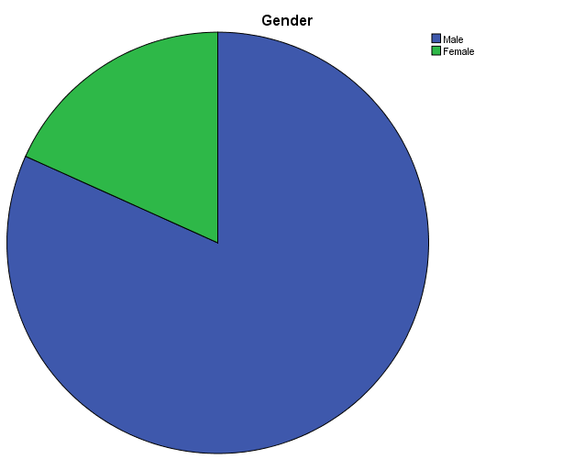

Chart: 4.1

**Interpretation:**

* The majority of the respondents belong to the category of males
* About 81.7 % of the total respondents are males
* About 18.3 % of the total respondents are female

|  |  |  |  |  |  |
| --- | --- | --- | --- | --- | --- |
| **Age Group** | | | | | |
|  | | Frequency | Percent | Valid Percent | Cumulative Percent |
| Valid | 18 – 25 Years | 101 | 87.8 | 87.8 | 87.8 |
| 26 – 35 Years | 13 | 11.3 | 11.3 | 99.1 |
| 36 – 45 Years | 1 | .9 | .9 | 100.0 |
| Total | 115 | 100.0 | 100.0 |  |

Table: 4.2

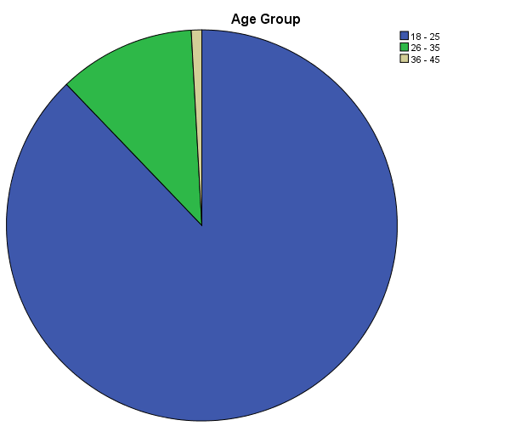

Chart: 4.2

**Interpretation:**

* Majority of the respondents belong to the category of 18 - 25 age group, 87.8 %
* About 11.3 % f the respondents belong to the category of 26 – 35
* About .9 % of the respondents belong to the category of 36 – 45
* There aren’t any respondents above 55 years.

|  |  |  |  |  |  |
| --- | --- | --- | --- | --- | --- |
| **Occupation** | | | | | |
|  | | Frequency | Percent | Valid Percent | Cumulative Percent |
| Valid | Service Class | 24 | 20.9 | 20.9 | 20.9 |
| Business Class | 9 | 7.8 | 7.8 | 28.7 |
| Student | 64 | 55.7 | 55.7 | 84.3 |
| Others | 18 | 15.7 | 15.7 | 100.0 |
| Total | 115 | 100.0 | 100.0 |  |

Table: 4.3

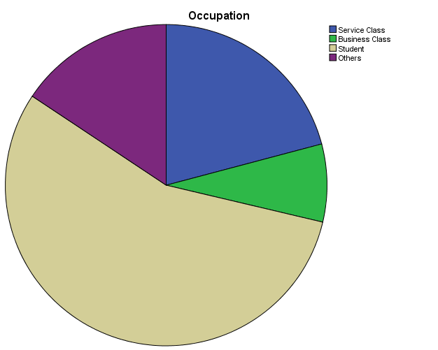

Chart: 4.3

**Interpretation:**

* Majority of the respondents belong to the students category, 55.7 %
* About 20.9 % of the respondents belong to the service class.
* Minority of the respondents belong to the business class, 7.8 %
* There are about 15.7 % respondents which belong to other categories

|  |  |  |  |  |  |
| --- | --- | --- | --- | --- | --- |
| **Annual Income** | | | | | |
|  | | Frequency | Percent | Valid Percent | Cumulative Percent |
| Valid | < 2.5 lakhs | 57 | 49.6 | 49.6 | 49.6 |
| 2.5 - 5 Lakhs | 42 | 36.5 | 36.5 | 86.1 |
| 5 - 10 Lakhs | 14 | 12.2 | 12.2 | 98.3 |
| > 10 Lakhs | 2 | 1.7 | 1.7 | 100.0 |
| Total | 115 | 100.0 | 100.0 |  |

Table: 4.4

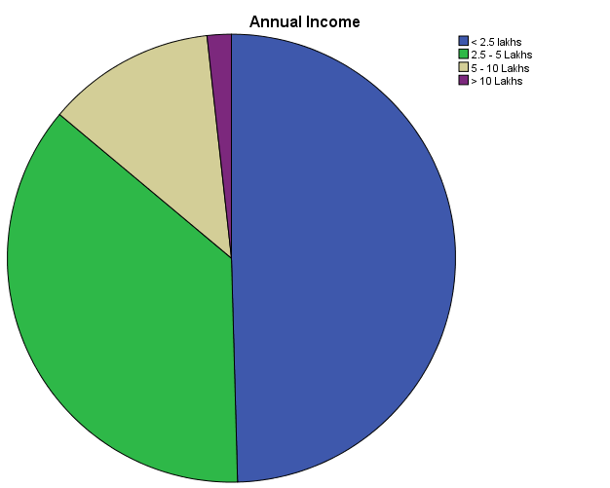

Chart: 4.4

**Interpretation:**

* Majority of the respondents belong to the category of income level less than 2 lakhs, 49.6 %.
* About 36.5 % of the respondents belong to the category of income Rs 2.5 lakhs - Rs 5 lakhs.
* About 12.2 % of the respondents belong to the category of income Rs. 5 lakhs - Rs.10 lakhs.
* There are about 1.7 % of the respondents who belong to the category above Rs. 10 lakhs.

|  |  |  |  |  |  |
| --- | --- | --- | --- | --- | --- |
| **Do you have a Bank account?** | | | | | |
|  | | Frequency | Percent | Valid Percent | Cumulative Percent |
| Valid | Yes | 108 | 93.9 | 93.9 | 93.9 |
| No | 7 | 6.1 | 6.1 | 100.0 |
| Total | 115 | 100.0 | 100.0 |  |

Table: 4.5

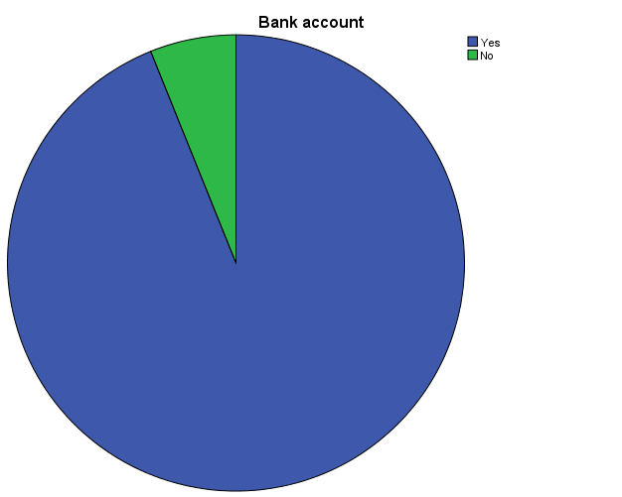

Chart: 4.5

**Interpretation:**

* About 93.9 % of the total respondents hold a traditional bank account.
* About 6.1 % of the total respondents don’t have a traditional bank account.

|  |  |  |  |  |  |
| --- | --- | --- | --- | --- | --- |
| **Do you have an Internet Banking facility with you?** | | | | | |
|  | | Frequency | Percent | Valid Percent | Cumulative Percent |
| Valid | Yes | 73 | 63.5 | 63.5 | 63.5 |
| No | 42 | 36.5 | 36.5 | 100.0 |
| Total | 115 | 100.0 | 100.0 |  |

Table: 4.6

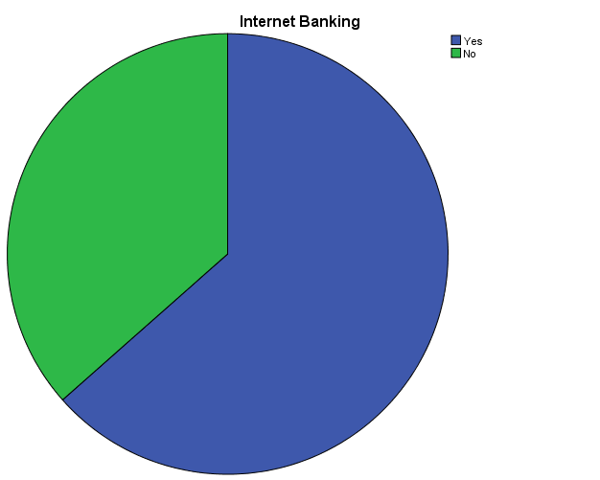

Chart: 4.6

**Interpretation:**

* About 63.5 % of the total respondents use an internet bank account.
* About 36.5 % of the total respondents don’t use an internet bank account.

|  |  |  |  |  |  |
| --- | --- | --- | --- | --- | --- |
| **How you access of internet banking facility?** | | | | | |
|  | | Frequency | Percent | Valid Percent | Cumulative Percent |
| Valid | Non users | 42 | 36.5 | 36.5 | 36.5 |
| Online Banking | 45 | 39.1 | 39.1 | 75.7 |
| Mobile Banking | 7 | 6.1 | 6.1 | 81.7 |
| Both | 21 | 18.3 | 18.3 | 100.0 |
| Total | 115 | 100.0 | 100.0 |  |

Table: 4.7

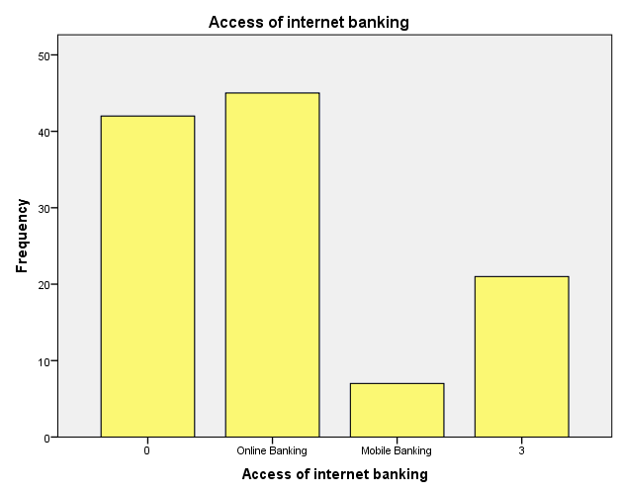

Chart: 4.7

**Interpretation**

* Out of 63.5 % of internet banking users 39.1 % of the internet banking users use online banking alone for accessing their internet banking facility.
* Out of the total internet banking users 6.1 % users use only mobile banking for accessing their internet banking facility.
* About 18.3 % of the internet banking user use both internet banking and mobile banking for accessing their internet banking facility.

|  |  |  |  |  |  |
| --- | --- | --- | --- | --- | --- |
| **Frequency of usage** | | | | | |
|  | | Frequency | Percent | Valid Percent | Cumulative Percent |
| Valid | Non users | 42 | 36.5 | 36.5 | 36.5 |
| Frequently | 42 | 36.5 | 36.5 | 73.0 |
| Occasionally | 30 | 26.1 | 26.1 | 99.1 |
| Never | 1 | .9 | .9 | 100.0 |
| Total | 115 | 100.0 | 100.0 |  |

Table: 4.8

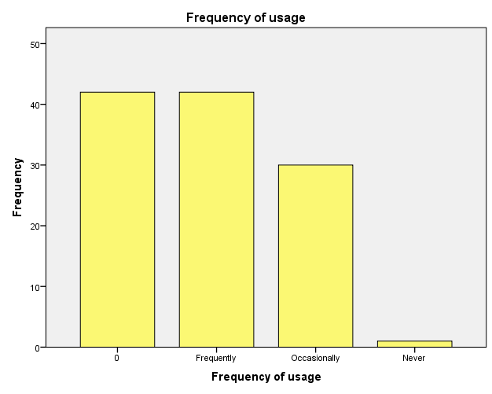

Chart: 4.8

**Interpretation**

* About 36.5 % of the internet banking users use internet banking facility frequently.
* About 26.1 % of the internet banking users occasionally uses their internet banking facility.
* There are about .9 % internet bank account holders who don’t use their internet banking facility yet.

|  |  |  |  |  |  |
| --- | --- | --- | --- | --- | --- |
| **Reason for choosing a particular bank** | | | | | |
|  | | Frequency | Percent | Valid Percent | Cumulative Percent |
| Valid | Non Users | 42 | 36.5 | 36.5 | 36.5 |
| I have a traditional bank account with the same bank. | 25 | 21.7 | 21.7 | 58.3 |
| The brand name of the bank | 5 | 4.3 | 4.3 | 62.6 |
| The excellent service offered by this bank | 17 | 14.8 | 14.8 | 77.4 |
| Security and trust in that bank | 13 | 11.3 | 11.3 | 88.7 |
| Others | 13 | 11.3 | 11.3 | 100.0 |
| Total | 115 | 100.0 | 100.0 |  |

Table: 4.9

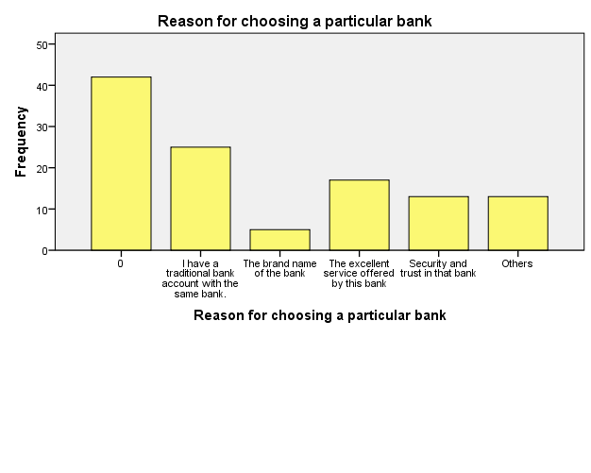

Chart: 4.9

**Interpretation**

* About 21.7 % of the internet banking users uses a particular bank for accessing internet bank facility because they have a traditional bank account with that bank.
* About 4.3 % of the internet banking users chooses a particular bank for availing internet banking facility based on the brand name of the bank.
* For choosing a particular bank for getting internet banking facility about 14.8 % internet banking users consider the excellent services offered by the bank.
* About 11.3 % internet banking users consider security and trust towards that as a major factor for choosing a particular bank for availing the internet banking facility.
* About 11.3 % of the internet banking users choose a particular bank’s internet banking facility because of other reasons

**Overall satisfaction**

|  |  |  |  |  |  |
| --- | --- | --- | --- | --- | --- |
| **Overall Satisfaction** | | | | | |
|  | | Frequency | Percent | Valid Percent | Cumulative Percent |
| Valid | 1.00 | 3 | 1.7 | 4.1 | 4.1 |
| 2.00 | 3 | 1.7 | 4.1 | 8.2 |
| 3.00 | 14 | 7.9 | 19.2 | 27.4 |
| 4.00 | 34 | 19.1 | 46.6 | 74.0 |
| 5.00 | 19 | 10.7 | 26.0 | 100.0 |
| Total | 73 | 41.0 | 100.0 |  |
| Missing | System | 105 | 59.0 |  |  |
| Total | | 178 | 100.0 |  |  |
|  | |  |  |  |  |

Table: 4.10

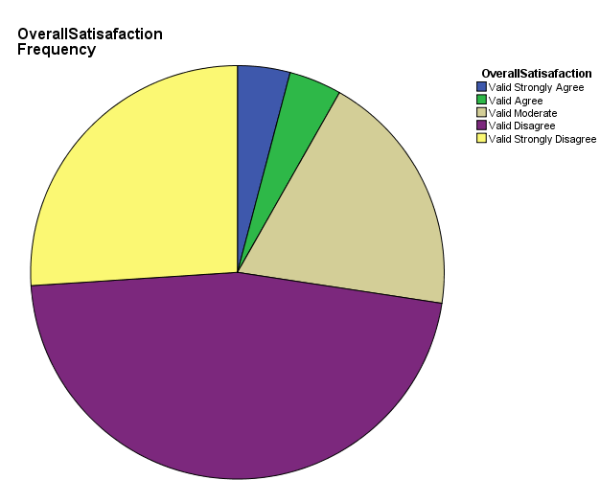

Chart: 4.10

**Interpretation**

* Overall satisfaction of the respondents towards internet banking facility is less and most of them are not satisfied with their internet banking facility.

**Reason for not opening an internet bank account**

|  |  |  |  |  |  |
| --- | --- | --- | --- | --- | --- |
| **Reason for not opening internet bank account** | | | | | |
|  | | Frequency | Percent | Valid Percent | Cumulative Percent |
| Valid | Non users | 1 | .6 | 2.6 | 2.6 |
| Concerned About Security | 11 | 6.2 | 28.2 | 30.8 |
| Haven't taken time to open Account | 21 | 11.8 | 53.8 | 84.6 |
| Don’t know how to use | 3 | 1.7 | 7.7 | 92.3 |
| Don’t see any real value | 2 | 1.1 | 5.1 | 97.4 |
| Other | 1 | .6 | 2.6 | 100.0 |
| Total | 39 | 21.9 | 100.0 |  |
| Missing | System | 139 | 78.1 |  |  |
| Total | | 178 | 100.0 |  |  |

Table: 4.11

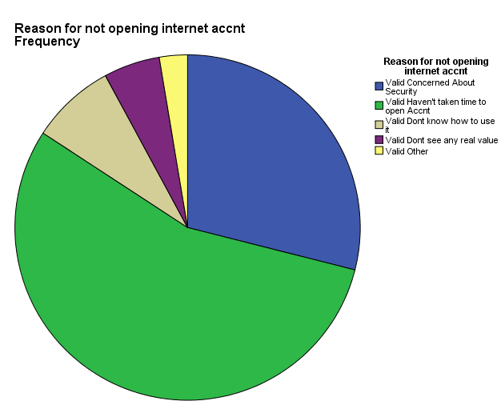

Chart: 4.11

**Interpretation:** Majority of respondents didn’t opened an internet bank account because they haven't taken time to open an account (53.8 %) and 28.2 % are concerned about security.

**DESCRIPTIVE ANALYSIS**

|  |  |  |  |  |  |
| --- | --- | --- | --- | --- | --- |
| **Priority of internet banking services used by customers** | | | | | |
|  | N | Minimum | Maximum | Mean | Std. Deviation |
| Bill payment | 73 | 1 | 5 | 4.00 | 1.333 |
| Fund Transfer | 73 | 1 | 5 | 3.52 | 1.608 |
| Online investment | 73 | 1 | 5 | 2.19 | 1.552 |
| Online shopping | 73 | 1 | 5 | 2.05 | 1.290 |
| E- ticket booking | 73 | 1 | 5 | 2.00 | 1.481 |
| Bank statement | 73 | 1 | 5 | 3.14 | 1.484 |
| Online recharge | 73 | 1 | 5 | 3.81 | 1.497 |
| Others | 73 | 1 | 5 | 2.37 | 1.439 |
| Valid N (listwise) | 73 |  |  |  |  |

Table: 4.12

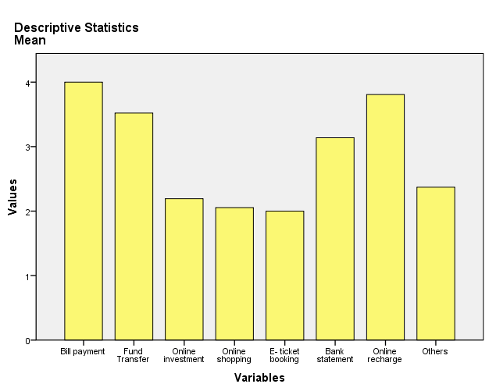

Chart: 4.12

**Interpretation**

Most of the internet banking users uses their internet banking facilities for making bill payments, online recharges and fund transfers.

**Internet banking experience based on various parameters**

|  |  |  |  |  |  |
| --- | --- | --- | --- | --- | --- |
| **Descriptive Statistics** | | | | | |
|  | N | Minimum | Maximum | Mean | Std. Deviation |
| Time saving | 115 | 0 | 5 | 2.73 | 2.241 |
| Easy to use ( user friendliness) | 115 | 0 | 5 | 2.57 | 2.078 |
| Authenticity and security | 115 | 0 | 5 | 2.39 | 1.981 |
| Accuracy of information | 73 | 1 | 5 | 2.07 | 1.045 |
| Reliability and convenience ( anywhere connectivity) | 115 | 0 | 5 | 2.56 | 2.128 |
| Good transaction speed | 115 | 0 | 5 | 2.41 | 2.047 |
| Reduce cost per transaction | 115 | 0 | 5 | 2.22 | 1.895 |
| Overall satisfied | 115 | 0 | 5 | 2.45 | 2.027 |
| Valid N (listwise) | 73 |  |  |  |  |

Table: 4.13

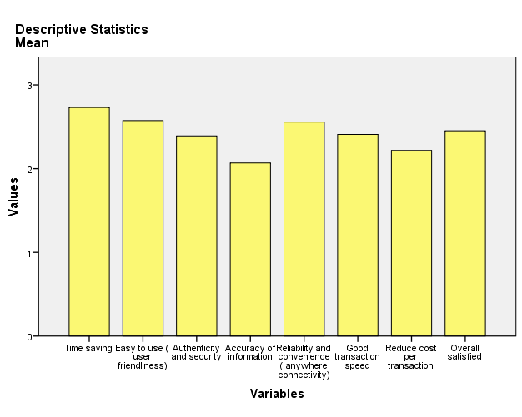

Chart: 4.13

**Interpretation:** Most of the internet banking users perceives that internet banking facility is time saving and easy to use and also perceive that it provides reliability and convenience.

|  |  |  |  |  |  |
| --- | --- | --- | --- | --- | --- |
| **Problems faced by internet banking users**  **Descriptive Statistics** | | | | | |
|  | N | Minimum | Maximum | Mean | Std. Deviation |
| Low speed and delay in transaction | 73 | 1 | 5 | 3.04 | 1.274 |
| Transaction failure | 73 | 1 | 5 | 2.81 | 1.114 |
| Security issues in internet dealings | 73 | 1 | 5 | 2.52 | 1.281 |
| Loss of money | 73 | 1 | 5 | 2.14 | 1.316 |
| Heavy traffic | 73 | 1 | 5 | 2.73 | 1.326 |
| Hidden charges for transactions | 73 | 1 | 5 | 2.51 | 1.345 |
| Lack of acknowledgement such as SMS , Email etc | 73 | 1 | 5 | 2.27 | 1.326 |
| One time password issues | 73 | 1 | 5 | 2.59 | 1.300 |
| Valid N (listwise) | 73 |  |  |  |  |

Table: 4.14

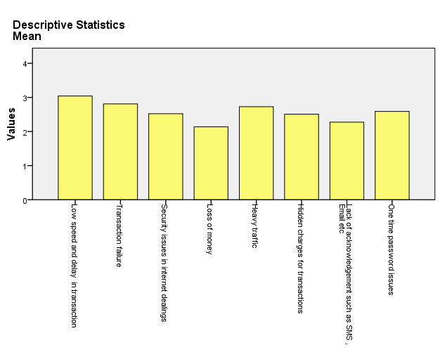

Chart: 4.14

**Interpretation:** The most frequently faced problems by internet banking users are low speed and delay in transaction, failure in transaction, one time password issue and heavy traffic in websites.

**MULTIPLE RESPONSE ANALYSIS**

**Which is the bank you have an internet bank account with?**

|  |  |  |  |  |
| --- | --- | --- | --- | --- |
| **Frequencies** | | | | |
|  | | Responses | | Percent of Cases |
| N | Percent |
|  | SBT | 24 | 22.6% | 32.9% |
| SBI | 26 | 24.5% | 35.6% |
| Federal Bank | 13 | 12.3% | 17.8% |
| South Indian Bank | 4 | 3.8% | 5.5% |
| Syndicate Bank | 1 | 0.9% | 1.4% |
| ICICI Bank | 11 | 10.4% | 15.1% |
| Canara bank | 4 | 3.8% | 5.5% |
| Other Banks | 23 | 21.7% | 31.5% |
| Total | | 106 | 100.0% | 145.2% |
| Table: 4.15 | | | | |

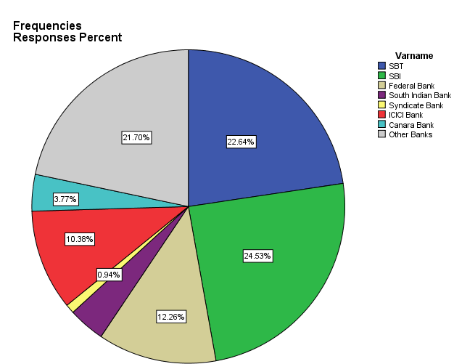

Chart: 4.15

**Interpretation:** About 24.53 % of the internet banking users uses SBI bank for their internet banking purposes and 22.64 % use internet banking facility of SBT bank. Syndicate bank (0.94%) and Canara bank (3.77%) are the least used banks for internet banking purposes.

**CHI- SQUARE TESTS**

**Age group and frequency of use**

H0: There is no relationship between age group and frequency of use of internet banking facility.

H1: There is relationship between age group and frequency of use of internet banking facility.

|  |  |  |  |
| --- | --- | --- | --- |
| **Chi-Square Tests** | | | |
|  | Value | df | Asymp. Sig. (2-sided) |
| Pearson Chi-Square | 6.610a | 6 | .358 |
| Likelihood Ratio | 7.282 | 6 | .296 |
| Linear-by-Linear Association | .290 | 1 | .590 |
| N of Valid Cases | 115 |  |  |

Table: 4.16

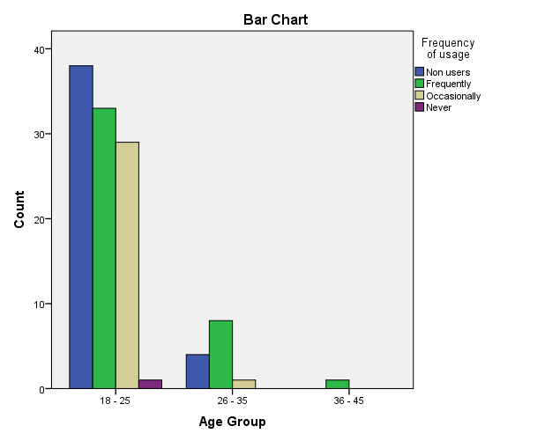

Chart: 4.16

**Interpretation**

Pearson Chi-square value is 6.610. Since the significant value is 0.318 which is greater than 0.05.So Ho is accepted. So there is no relationship between gender and frequency of use of internet banking facility.

**Age group and mode of accessing of internet bank account**

H0: There is no relationship between age group and mode used for accessing internet bank account.

H1: There is relationship between age group and mode used for accessing internet bank account.

|  |  |  |  |
| --- | --- | --- | --- |
| **Chi-Square Tests** | | | |
|  | Value | df | Asymp. Sig. (2-sided) |
| Pearson Chi-Square | 6.083a | 6 | .414 |
| Likelihood Ratio | 6.522 | 6 | .367 |
| Linear-by-Linear Association | 1.479 | 1 | .224 |
| N of Valid Cases | 115 |  |  |
| Table: 4.17 | | | |

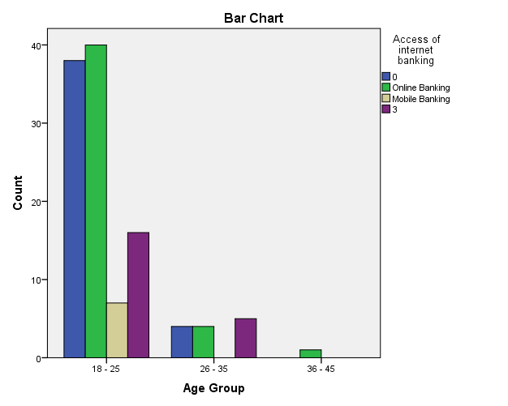

Chart: 4.17

**Interpretation:** Pearson Chi-square value is 6.083. Since the significant value is 0.414 which is greater than 0.05.So Ho is accepted. So there is no relationship between age group and mode used for accessing internet bank account.

**Annual income and reason for choosing a particular bank**

H0: There is no relationship between annual income and reason for choosing a particular bank

H1: There is relationship between annual income and reason for choosing a particular bank

|  |  |  |  |
| --- | --- | --- | --- |
| **Chi-Square Tests** | | | |
|  | Value | df | Asymp. Sig. (2-sided) |
| Pearson Chi-Square | 18.450a | 15 | .240 |
| Likelihood Ratio | 20.052 | 15 | .170 |
| Linear-by-Linear Association | 1.167 | 1 | .280 |
| N of Valid Cases | 115 |  |  |
| Table: 4.18 | | | |

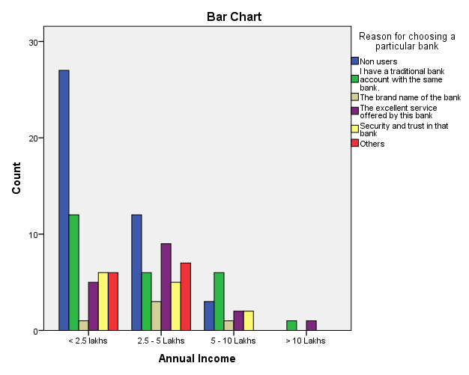

Chart: 4.18

**Interpretation:** Pearson Chi-square value is 18.450. Since the significant value is 0.240 which is greater than 0.05.So Ho is accepted. So there is no relationship between annual income and reason for choosing a particular bank.

**Gender and use of internet banking facility**

H0: There is no relationship between gender and use of internet banking facility.

H1: There is relationship between gender and use of internet banking facility.

|  |  |  |  |  |  |
| --- | --- | --- | --- | --- | --- |
| **Chi-Square Tests** | | | | | |
|  | Value | df | Asymp. Sig. (2-sided) | Exact Sig. (2-sided) | Exact Sig. (1-sided) |
| Pearson Chi-Square | 4.712a | 1 | .030 |  |  |
| Continuity Correctionb | 3.687 | 1 | .055 |  |  |
| Likelihood Ratio | 4.550 | 1 | .033 |  |  |
| Fisher's Exact Test |  |  |  | .044 | .029 |
| Linear-by-Linear Association | 4.671 | 1 | .031 |  |  |
| N of Valid Cases | 115 |  |  |  |  |

Table: 4.19

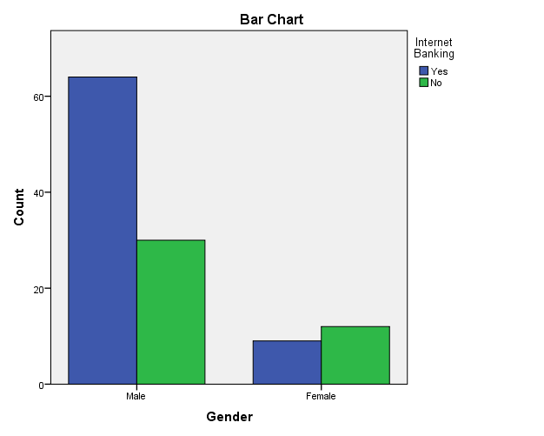

Chart: 4.19

**Interpretation:** Pearson Chi-square value is 4.712. Since the significant value is 0.03 which is less than 0.05.So Ho is rejected. So there is relationship between gender and use of internet banking facility

**Annual income and use of internet banking facility**

H0: There is no relationship between annual income and use of internet banking facility.

H1: There is relationship between annual income and use of internet banking facility.

|  |  |  |  |
| --- | --- | --- | --- |
| **Chi-Square Tests** | | | |
|  | Value | df | Asymp. Sig. (2-sided) |
| Pearson Chi-Square | 6.564a | 3 | .087 |
| Likelihood Ratio | 7.299 | 3 | .063 |
| Linear-by-Linear Association | 6.188 | 1 | .013 |
| N of Valid Cases | 115 |  |  |

Table: 4.20

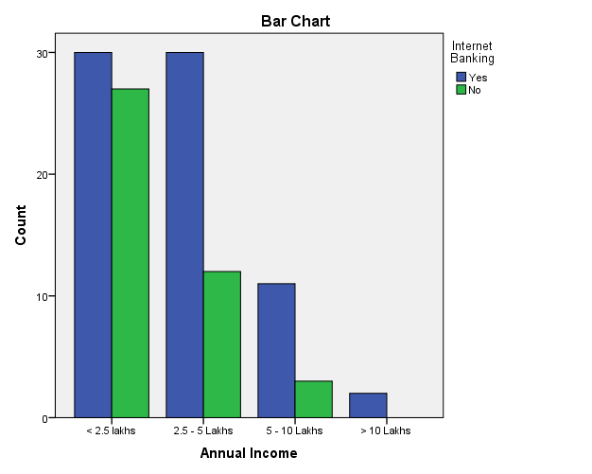

Chart: 4.20

**Interpretation**

Pearson Chi-square value is 6.564. Since the significant value is 0.087 which is greater than 0.05.So Ho is accepted. So there is no relationship between annual income and use of internet banking facility.

**Occupation and mode used for accessing internet banking facility**

H0: There is no relationship between occupation and mode used for accessing internet banking facility.

H1: There is relationship between occupation and mode used for accessing internet banking facility.

|  |  |  |  |
| --- | --- | --- | --- |
| **Chi-Square Tests** | | | |
|  | Value | df | Asymp. Sig. (2-sided) |
| Pearson Chi-Square | 21.121a | 9 | .012 |
| Likelihood Ratio | 23.269 | 9 | .006 |
| Linear-by-Linear Association | 8.338 | 1 | .004 |
| N of Valid Cases | 115 |  |  |

Table: 4.21

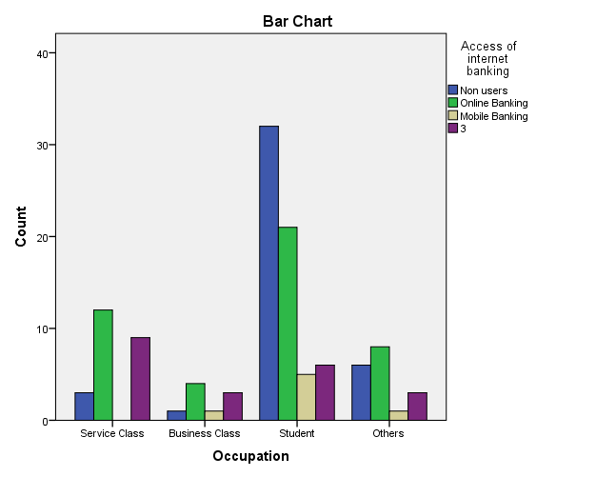

Chart: 4.21

**Interpretation**

Pearson Chi-square value is 21.121. Since the significant value is 0.012 which is less than 0.05.So Ho is rejected. So there is relationship between occupation and mode used for accessing internet banking facility.

**Occupation and frequency of use of internet banking facility**

H0: There is no relationship between occupation and frequency of use of internet banking facility.

H1: There is relationship between occupation and frequency of use of internet banking facility.

|  |  |  |  |
| --- | --- | --- | --- |
| **Chi-Square Tests** | | | |
|  | Value | df | Asymp. Sig. (2-sided) |
| Pearson Chi-Square | 29.346a | 9 | .001 |
| Likelihood Ratio | 29.745 | 9 | .000 |
| Linear-by-Linear Association | .159 | 1 | .690 |
| N of Valid Cases | 115 |  |  |

Table: 4.22

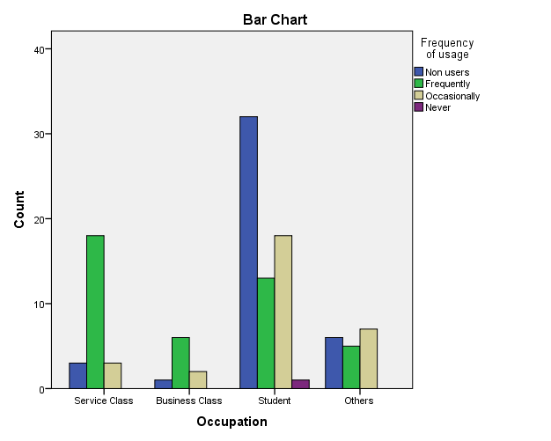

Chart: 4.22

**Interpretation**

Pearson Chi-square value is 29.346. Since the significant value is 0.001 which is less than 0.05.So Ho is rejected. So there is relationship between occupation and frequency of use of internet banking facility.

**RELIABILITY ANALYSIS**

**Parameters influencing the perception of customer toward internet banking**.

|  |  |
| --- | --- |
| **Reliability Statistics** | |
| Cronbach's Alpha | N of Items |
| .772 | 8 |

Table: 4.23

|  |  |  |  |
| --- | --- | --- | --- |
| **Item Statistics** | | | |
|  | Mean | Std. Deviation | N |
| Time saving | 4.30 | 1.050 | 73 |
| Easy to use ( user friendliness) | 4.05 | .864 | 73 |
| Authenticity and security | 3.77 | .979 | 73 |
| Accuracy of information | 2.07 | 1.045 | 73 |
| Reliability and convenience ( anywhere connectivity) | 4.03 | 1.080 | 73 |
| Good transaction speed | 3.79 | 1.142 | 73 |
| Reduce cost per transaction | 3.49 | 1.082 | 73 |
| Overall satisfied | 3.86 | .990 | 73 |

Table: 4.24

**Interpretation:**

Since the value ofCronbach's Alpha (.772) is greater than 0.7, the 8 factors which chosen are reliable.

**ONEWAY ANNOVA**

H0: There is no difference in the ranking of various factors influencing banking experience and income level.

H1: There is difference in the ranking of various factors influencing banking experience and income level.

|  |  |  |  |  |  |  |
| --- | --- | --- | --- | --- | --- | --- |
| **ANOVA** | | | | | | |
|  | | Sum of Squares | df | Mean Square | F | Sig. |
| Time saving | Between Groups | 45.636 | 3 | 15.212 | 3.204 | .026 |
| Within Groups | 527.008 | 111 | 4.748 |  |  |
| Total | 572.643 | 114 |  |  |  |
| Easy to use ( user friendliness) | Between Groups | 30.182 | 3 | 10.061 | 2.417 | .070 |
| Within Groups | 461.940 | 111 | 4.162 |  |  |
| Total | 492.122 | 114 |  |  |  |
| Authenticity and security | Between Groups | 35.475 | 3 | 11.825 | 3.187 | .027 |
| Within Groups | 411.916 | 111 | 3.711 |  |  |
| Total | 447.391 | 114 |  |  |  |
| Accuracy of information | Between Groups | 1.215 | 3 | .405 | .361 | .781 |
| Within Groups | 77.442 | 69 | 1.122 |  |  |
| Total | 78.658 | 72 |  |  |  |
| Reliability and convenience ( anywhere connectivity) | Between Groups | 34.898 | 3 | 11.633 | 2.682 | .050 |
| Within Groups | 481.485 | 111 | 4.338 |  |  |
| Total | 516.383 | 114 |  |  |  |
| Good transaction speed | Between Groups | 36.897 | 3 | 12.299 | 3.096 | .030 |
| Within Groups | 440.895 | 111 | 3.972 |  |  |
| Total | 477.791 | 114 |  |  |  |
| Reduce cost per transaction | Between Groups | 36.170 | 3 | 12.057 | 3.584 | .016 |
| Within Groups | 373.395 | 111 | 3.364 |  |  |
| Total | 409.565 | 114 |  |  |  |
| Overall satisfied | Between Groups | 32.154 | 3 | 10.718 | 2.727 | .048 |
| Within Groups | 436.333 | 111 | 3.931 |  |  |
| Total | 468.487 | 114 |  |  |  |

Table: 25

**Interpretation:**

* From the table it is clear that for the factors such as time saving, Authenticity and security, Reliability and convenience (anywhere connectivity), Good transaction speed, Reduce cost per transaction, Overall satisfaction have significance level is less than 0.05, it means there is significant variations exists between the views of respondents belonging to different income group. So here our null hypothesis (There is no difference in ranking of various factors influencing banking experience and income level) is rejected.
* For factors such as Easy to use (user friendliness) and Accuracy of information null hypothesis is accepted as significance level is greater than 0.05. So there is no difference in the ranking of various factors influencing banking experience and income level.

**CHAPTER 5**

**FINDINGS AND CONCLUSIONS**

**5-FINDINGS AND SUGGESTIONS**

* 1. **FINDINGS**
* The study found that majority of the respondents is males 81.7% and 18.3 % were females.
* Majority of the respondents belong to the category of 18 - 25 age group 87.8% i.e. youth category, 11.3 % f the respondents belong to the category of 26 – 35 and 0.9 % of the respondents belong to the category of 36 – 45 and there is no respondents above 55 years.
* In this study majority of respondents belong to the student category 55.7 %, about 20.9 % belongs to service class, about 7.8 % belongs to the business class and 15.7 % belongs to other categories.
* About 49.6 % of the respondents belong to the category of income level less than 2 lakhs, 36.5 % of the respondents belong to the category of income Rs 2.5 lakhs - Rs 5 lakhs, 12.2 % of the respondents belong to the category of income Rs. 5 lakhs - Rs.10 lakhs and there are about 1.7 % of the respondents who belong to the category above Rs. 10 lakhs.
* About 93.9 % of the total respondents hold a traditional bank account and 6.1 % of the total respondents don’t have a traditional bank account.
* From the analysis we can say that about 63.5 % of the total respondents use an internet bank account and 36.5 % of the total respondents don’t use an internet bank account.
* Out of 63.5 % of internet banking users 39.1 % of the internet banking users use online banking, 6.1 % use mobile banking and 18.3 % use both online banking and mobile banking for accessing their internet banking facility.
* About 36.5 % of the internet banking users use internet banking facility frequently, 26.1 % use occasionally and there are about 0.9 % internet bank account holders who don’t use their internet banking facility yet.
* From the analysis it is found that about 21.7 % of the internet banking users chooses a particular bank for accessing internet bank facility because they have a traditional bank account with that bank and 14.8 % internet banking users chooses based on the excellent services offered by the bank.
* About 11.3 % internet banking users consider security and trust towards the bank, 4.3 % consider the brand name of the bank as a major factor for choosing a particular bank and about 11.3 % of the internet banking users choose a particular bank’s internet banking facility because of other reasons.
* Overall satisfaction of the respondents towards internet banking facility is less and most of them are not satisfied with their internet banking facility.
* Majority of respondents didn’t opened an internet bank account because they haven't taken time to open an account (53.8 %) and 28.2 % are concerned about security.
* From the analysis it is found that most of the internet banking users uses their internet banking facilities for making bill payments, online recharges and fund transfers.
* Most of the internet banking users perceives that internet banking facility is time saving and easy to use and also perceive that it provides reliability and convenience.
* From the analysis it is found that most of the respondents face problems such as low speed and delay in transaction, failure in transaction, one time password issue and heavy traffic in websites while using the internet banking facility.
* Majority of the internet banking users uses SBI bank for their internet banking purposes (24.53 %), 22.64 % use internet banking facility of SBT bank, 12.26 % users use Federal bank, 10.38% use ICICI bank and 21.70 % use other banks for accessing internet banking facility. Syndicate bank (0.94%) and Canara bank (3.77%) are the least used banks for internet banking purposes.
* The statistical dependence between age group and frequency of use of internet banking facility is tested with Chi-square. Hence the null hypothesis is accepted. So it is found that there is no relationship between age group and frequency of use.
* The statistical dependence between age group and mode used for accessing internet bank account is tested with Chi-square. Hence the null hypothesis is accepted. So it is found that there is no relationship between age group and mode used for accessing internet bank account.
* The statistical dependence between annual income and reason for choosing a particular bank is tested with Chi-square. Hence the null hypothesis is accepted. So it is found that there is no relationship between annual income and reason for choosing a particular bank.
* The statistical dependence between gender and use of internet banking facility is tested with Chi-square. Hence the null hypothesis is rejected. So it is found that there is relationship between gender and use of internet banking facility.
* The statistical dependence between annual income and use of internet banking facility is tested with Chi-square. Hence the null hypothesis is accepted. So it is found that there is no relationship annual income and use of internet banking facility.
* The statistical dependence between occupation and mode used for accessing internet banking facility is tested with Chi-square. Hence the null hypothesis is rejected. So it is found that there is relationship occupation and mode used for accessing internet banking facility.
* The statistical dependence between occupation and frequency of use of internet banking facility is tested with Chi-square. Hence the null hypothesis is rejected. So it is found that there is relationship between occupation and frequency of use of internet banking facility.
* From the analysis the value ofCronbach's Alpha (.772) is greater than 0.7 so the 8 factors which influence the internet banking experience chosen are reliable.
* From the analysis it is found that the factors such as time saving, Authenticity and security, Reliability and convenience (anywhere connectivity), Good transaction speed, Reduce cost per transaction, Overall satisfaction have significance level is less than 0.05, it means there is significant variations exists between the views of respondents belonging to different income group. For factors such as Easy to use (user friendliness) and Accuracy of information null hypothesis is accepted as significance level is greater than 0.05. So there is no difference in the ranking of various factors influencing banking experience and income level.
  1. **SUGGESTIONS**
* Males have higher attitude towards Internet banking than females. 81.7 percent of Internet banking users is male. So banks need to encourage females to use internet banking facility.
* From the study it is found that age plays a crucial role in the usage of internet banking facility. So banks need to formulate marketing plans based on age groups.
* The influence of gender, age and occupation should be given importance while marketing implications of demographics in Internet banking
* Bankers need to build, maintain, and enhance customer relationships in this tough competitive environment through internet banking.
* Give proper training to customers for using internet banking facility to overcome the problems faced by customers due to lack of knowledge in it.
* Create security and trust in mind of customers towards internet banking facility.
* Provide a platform from where the customers can access different accounts at single time without extra charge.
* Make the internet banking sites and facilities more users friendly.
* The results of this study indicate that it would be a valuable strategy for marketers to rethink how to educate potential customers and promote Internet banking using innovation characteristics
* Customers should be motivated to use Internet banking facilities through customer education campaigns.
* The low speed and delay in transaction need to overcome through proper site designing and networking.
* Banks need to take necessary steps to prevent failure in transactions.
* Queue management should be done to prevent heavy traffic in sites and banks need to ensure customer satisfaction.
* Customers are mainly concerned on safety issues so the banks should educate their customers on the safety use of their passwords and pin numbers and it should insist the customers that they should change the passwords and pin numbers frequently so no unauthorized fraudulent practices happen in the internet banking.

**6 CONCLUSIONS**

There is still a lot needed for the banking system to make reforms and train their customers for using internet for their banking account. Going through the survey the main problem lies that still customer have a fear of hacking of accounts and thus do not go on for internet banking. Banks are trying their level best by providing the best security options to the customers but then to there is lot of factors which betrays a customer from opening an internet bank account. Banks are providing free internet banking services also so that the customers can be attracted. The maximum numbers of internet bank account holders are males, youth and service class. If proper training should be given to customer by the bank employs to open an account will be beneficial secondly the website should be made friendlier from where the first time customers can directly make and access their accounts.

When investigating all the variables and the response by consumers, this study reveals that the perception of the consumers can be changed by factors such as time saving, Authenticity and security, Reliability and convenience (anywhere connectivity), Good transaction speed, Reduce cost per transaction, Overall satisfaction. The study also provides the kind of correlation between different factors. As per our basic assumptions we consider only those consumers who know how to use Internet and have an access to Internet, and our study considered only the situation wherein banks provide Internet banking services.

In case of the consumers who don’t use Internet banking services, having all facilities at their disposal, technology was not the biggest issue. The first thing that all bankers should concern about is the requirement of awareness. Even though these people are inclined towards the manual banking, these can be turned to potential customers, it is well proven thing, which says the surrounding influences the individual’s behavior or in India only environment that surrounds the public determines the behavior and decisions of the individuals. So if consumer sees most of their colleagues or friends who surround him using Internet banking then it may influence his decision to follow Internet banking option.

**BIBLIOGRAPHY**

**BIBLIOGRAPHY**

**Books & Articles Referred**

1. Barczak G.E, Scholder P. & Piling B.K.T. (1997), Developing typologies of consumer motivation for use of technologically based banking services, Journal of Business Research Vol. 38, No. 2, pp.131-40.
2. Benamati S. and Serva K. (2007), “Innovation characteristics and innovation adoption implementation: a Meta analysis of findings‟‟, IEEE Transaction of Engineering Management, Vol. 29, pp.34-52.
3. Black, N.J., Lockett, A., Winklhofer, H. and Ennew, C. (2001), The adoption of internet financial services: a qualitative study, International Journal of Retail & Distribution Management, Vol.29,No.8, pp.390-398.
4. Danniel E. & Storey C. (1997), Online banking Strategies & Management Challenges, Long Range Planning,Vol.30, No. 6, pp.890-8.
5. Daniel, E. (1999), Provision of electronic banking in the UK and Republic of Ireland, International Journal of Bank Marketing, Vol.17, No.2, pp.72-82.
6. Devlin J. F. & Young Matthew (2003), Insight in to customer motivation for switching to Internet Banking, Int. Rev. of Retail, Distribution & Consumer Research, Vol.13, No.4, pp.375-392.
7. Flavian, C., Torres, E., & Guinaliu, M. (2004). “Corporate image measurement a further problem for the tangibilization of Internet banking services”. International Journal of Bank Marketing, Vol. 32 No. 3, pp.107-125.
8. Gan, C., Clemes, M., Limsombunchai, V., & Weng, A. (2006). “A Logit analysis of electronic banking in New Zealand”, Discussion Paper No. 108, Commerce Division, Lincoln University, Canterbury
9. Eastin, M.S. (2002), “Diffusion of e-commerce: an analysis of the adoption of four e-commerce activities”, Telematics and Informatics, Vol. 19 No. 3, pp. 251-67.
10. Malhotra, P. and Singh, B. (2010), “An analysis of internet banking offerings and its determinants in India”, Internet Research, Vol. 20 No. 1, pp. 87-106.
11. Mols, N. (2000), The Internet and service marketing – the case of Danish retail banking. Internet Research: Electronic Networking Applications and Policy, 10 (1), 7-18.
12. Sana Haider Sumra et.al(2011) ،“Impact of E-Banking on the Profitability of Banks: A Study of Pakistani Banks” Journal of Public Administration and Governance ISSN 2161-7104 2011 ،Vol.1 ،No.1
13. Brodie, H Winklhofer et. al(2007) . Is e-marketing Coming of Age? An Examination of the Penetration of e-marketing and Firm Performance. J. Innterac. Market, 21:2-21.
14. Paramasivan, C. (2011), “Customer Satisfaction through Information Technology in Commercial Banks”, Journal of Commerce & Management, Vol. 2, No.4, pp. 509-522.
15. Mishra A K (2005), “Internet Banking in India Part-I”, http://www.banknetindia.com/ banking/ibkg.html, 15 Sept. 2010.
16. Grönroos, C., 1982. Strategic management and marketing in the service sector. Helsingfors, Finland: Swedish School of Economics and Business Administration.
17. Ahasanul Haque et al (2009). Issues of E-Banking Transaction: An Empirical Investigation on Malaysian
18. Customers Perception. Journal of applied Sciences. (Retrived from www.ebsco.com on 20 March 2009)
19. Gonzalez, M.E et al (2008). An Alternative Approach in Service Quality: An E-Banking Case Study. Quality Manage, 15: 41-48
20. Hiltunen, M., Laukka, M., & Luomala, J. (2002). Mobile User Experience. Helsinki: IT Press
21. Rafiu Oyesola Salawu et.al, (2007). The Emergence of Internet Banking in Nigeria: An Appraisal. Information Technology Journal 6 (4): 490-496
22. Karjaluoto. H. Mattila. M. and Pento. T, “Factors underlying attitude formation towards online banking in Finland”, International Journal of Bank Marketing, Vol. 20 No. 6, 2002, pp. 261-72
23. Jayawardhena. C. and Foley. P, “Changes in the banking sector: the case of internet banking in the UK”, Internet Research: Electronic Networking Applications and Policy, Vol. 10 No. 1, 2000, pp. 19-30
24. Mols. Niels, “The Behavioural Consequences of PC banking. International Journal of Bank Marketing”, 16, 5, 1998, pp. 195–201
25. Turban, E., Lee, J., King, D., and Chung, H.M. Electronic Commerce: A Managerial Perspective. Prentice-Hall, Upper Saddle River, NJ,2000
26. Friedman, B., Kahn, P.H. Jr and Howe, D.C. (2000). Trust online. Communications of the ACM, Vol. 43 No. 12, pp.34-40.
27. Davis, F., D. (1993). User Acceptance of Information Technology :System Characteristics ,User Perceptions and Behavioral Impacts, Intonation Journal of Man machine Studies ,Mar 1993, 38,(3) 475-487 Letter, No.163, P1
28. Giannakoudi, S. (1999) “Internet Banking: the Digital Voyage of Banking and Money in Cyberspace”, Information and Communications Technology Law, Vol.8, No. 3, pp.205-243.
29. Gerdes, Geoffrey, R., and Walton, J.K. (2002) “The Use of Checks and Other Noncash Payment Instruments in the United States”, Federal Reserve Bulletin, pp. 360-370
30. Rose, Peter S., and Hudgins, S.C. (2005) “Bank Management and Financial Services”, McGraw-Hill Irwin, New York.
31. Rogers, E. (1985) Diffusion of Innovations [NY: Free press]
32. David, M. (2007) “Culture, Context and Behaviour”, Journal of Personality, 75(6), 1285–1320.
33. Joseph, et al. (2003). Service quality in the banking sector: the impact of technology on service delivery. International Journal of Bank Marketing, 17 (4), 182-91
34. Barczak, G.E., Scholder, P., & Piling, B.K.T. (1997). Developing typologies of consumer motivation for use of technologically based banking services. Journal of Business Research, 38 (2), 131-40
35. Mohammed Sadique Khan, Siba Sankar Mahapatra and Sreekumar(2009). Service Quality Evaluation in Internet Banking: An Empirical Study in India, Int. J. Indian Culture and Business Management, 2(1)
36. Rafiu Oyesola Salawu et.al, (2007). The Emergence of Internet Banking in Nigeria: An Appraisal. Information Technology Journal 6 (4): 490-496
37. Srivastva Saurabh (2009). Internet Banking - A Global Way to Bank, Retrieved from http://www.indianmba.com/Faculty\_Column/FC908/fc908.html on 18 March 2009.
38. Suganthi, Balachandher, and Balachandran, (2001) Internet Banking Patronage: An Empirical Investigation of Malaysia. Journal of Internet Banking and Commerce, 6 (1). Retrieved from http://www.arraydev.com/commerce/JIBC/0103\_01.htm. Provision of electronic banking in the UK and the republic of Ireland”, Journal: International Journal of Bank Marketing; year; 1999 volume; 17 Issue: 2 Page: 72-83.
39. Riquelme. E. H (2009) “Internet Banking Customer satisfaction and Online Service Attributes” Journal of internet banking and commerce, Vol. 14, no. 2
40. Sayar and Wolfe (2007) and Eriksson et al.(2008)"Diffusion of internet banking amongst educated consumers in a high income non-OECD country", Journal of Internet Banking and Commerce, Vol. 11 No. 3

**APPENDIX**

**QUESTIONNAIRE**

Dear respondents,

My name is **Divya Rachel Johns** and I am pursuing MBA. As part of the curriculum, I am required to do a research to identify the perception of customers towards internet banking in the State of Kerala. So I need to ask some questions in this regard, and in the process I would be taking some of your valuable time. All information provided by you shall be used for academic purpose only.

**Gender**

 Male

 Female

**Age group**

 18 - 25

  26 - 35

 36 - 45

 46 - 55

 55+

**Occupation**

 Service class

 Business class

 Student

 Others

**Annual income range**

Students enter family income

 < 2.5 Lakhs

 2.5 - 5 Lakhs

 5 - 10 Lakhs

 > 10 Lakhs

**Do you have a bank account?**

 Yes

 No

**Do you have an internet banking facility with you?**

 Yes

 No

**FOR USERS OF INTERNET BANKING FACILITY**

**How you access your internet banking facility?**

 Online banking

 Mobile banking

 Both

**How often, do you use internet banking for the transaction purposes?**

 Frequently

 Occasionally

 Never

**Which is the bank you have an internet bank account with?**

 SBT

 SBI

 Federal Bank

 South Indian Bank

 Syndicate Bank

 ICICI

 Canara Bank

 Other: 

**What are the reasons you opened an internet bank account?**

Mark all that apply

 Reliability (24 hr service, anywhere internet connectivity)

 Convenience (easy to maintain banking transactions)

 Saving cost

 Online shopping

 Safe and secure

 Curiosity

**What was the most important reason that you choose this particular bank as your internet bank?**

 I have a traditional bank account with the same bank.

 The brand name of the bank

 The excellent service offered by this bank

 Security and trust in that bank

 Others

**What are the online banking services you use?**

Rate the following, 1 - Most frequently used service, 5 - Least used service

|  | 1 | 2 | 3 | 4 | 5 |
| --- | --- | --- | --- | --- | --- |
| Bill payment |  |  |  |  |  |
| Fund Transfer |  |  |  |  |  |
| Online investment |  |  |  |  |  |
| Online shopping |  |  |  |  |  |
| E- ticket booking |  |  |  |  |  |
| Bank statement |  |  |  |  |  |
| Online recharge |  |  |  |  |  |
| Other |  |  |  |  |  |
|  |  |  |  |  |  |

**Rank the following parameters based on your internet banking experience?**

|  | 1 | 2 | 3 | 4 | 5 | 6 | 7 | 8 |
| --- | --- | --- | --- | --- | --- | --- | --- | --- |
| Time saving |  |  |  |  |  |  |  |  |
| Easy to use ( user friendliness) |  |  |  |  |  |  |  |  |
| Authenticity and security |  |  |  |  |  |  |  |  |
| Upto date and accurate information |  |  |  |  |  |  |  |  |
| Reliability and convenience ( anywhere connectivity) |  |  |  |  |  |  |  |  |
| Good transaction speed |  |  |  |  |  |  |  |  |
| Reduce cost per transaction |  |  |  |  |  |  |  |  |
| Overall satisfied |  |  |  |  |  |  |  |  |

**Did you face any of the problems while using internet banking facility?**

Rate the following, 1 - most frequently faced, 5 - least faced.

|  | 1 | 2 | 3 | 4 | 5 |
| --- | --- | --- | --- | --- | --- |
| Low speed and delay  in transaction |  |  |  |  |  |
| Transaction failure |  |  |  |  |  |
| Security issues in internet dealings |  |  |  |  |  |
| Loss of money |  |  |  |  |  |
| Heavy traffic |  |  |  |  |  |
| Hidden charges for transactions |  |  |  |  |  |
| Lack of acknowledgement such as SMS , Email etc |  |  |  |  |  |
| One time password issues |  |  |  |  |  |

**FOR NON USERS OF INTERNET BANKING FACILITY**

**What are the main reasons that you have not opened an internet bank account yet?**

Check all that apply

 Never heard of internet banking

 Concerned about security

 Haven't taken time to open an internet bank account

 Not available through my bank

 Don't know how to use it

 Don't see any real value in having this type of account

 Other: